LTO Appendix F – Life Cycle Analyses

Attachment X, CVPIA spring-run life cycle model

This page intentionally left blank

## Model Overview

USFWS and Reclamation have been working to develop lifecycle models for use in structured decision making for CVPIA. Through a participatory process, the Science Integration Team (SIT) has developed a spring-run Chinook Salmon decision support model, or DSM. This model has been peer-reviewed and is publicly available. The participatory team’s model proposals and meeting notes, background, documentation, and code for the model are available at: [Resources - CVPIA Science Integration Team](https://cvpia.scienceintegrationteam.com/cvpia-sit/resources).  Reclamation used the SIT DSM in the LTO lifecycle analyses.

## Methods

### Model Development

The CVPIA SIT DSM models were developed by the CVPIA Science Integration Team (SIT) as part of a Structured Decision-Making (SDM) process. The SIT is a collaborative team of stakeholders and scientists. The resulting decision support models (DSMs) are open source and publicly available ([DSM R Packages - CVPIA Science Integration Team](https://cvpia.scienceintegrationteam.com/cvpia-sit/resources/dsm-r-packages)). An early version of the DSMs has been published in a peer-reviewed publication (Peterson and Duarte 2020). The models were parameterized and calibrated using a combination of empirical data, existing models, analysis of existing data, and expert opinion.

DSMs were created for fall-, winter-, and spring-run Chinook salmon to compare how habitat restoration actions might improve natural production of each run. The DSMs are stochastic or deterministic stage-based life cycle models (LCMs) that track the number of Chinook salmon across juvenile size classes and adult stages of natural and hatchery origin. The transitions between stages are estimated with survival, growth, and movement submodels. Model inputs include existing habitat areas, fish harvest rates, water diversions, flows, and temperatures. Flow information was obtained from CalSim II outputs. Temperature data are primarily obtained from HEC-5Q outputs. Some areas for which HEC-5Q data were unavailable have temperatures modeled based on measured water temperatures, statistical models relating water temperature to air temperature, or matching of tributaries with similar hydrology and geomorphology. Habitat inputs are primarily based on previously published flow-habitat relationships. Where flow-habitat relationship information is not available, relationships were assumed to be similar to those of nearby, geomorphically similar watersheds. All other inputs except for predator prevalence are obtained from previously published sources.

For the purposes of LTO analyses, Reclamation used the model structure from the peer-reviewed, published version of the DSMs, instead of more recent versions with updated model processes and calibrations, based on recommendations from model developers and an emphasis on peer-reviewed model processes. The winter-run and spring-run DSMs were cloned by Reclamation staff from GitHub at the following URLs: <https://github.com/CVPIA-OSC/winterRunDSM/tree/main> and <https://github.com/CVPIA-OSC/springRunDSM/tree/v1.0>. These models required Reclamation to download the following data repositories from the FlowWest GitHub site: cvpiaHabitat ([https://github.com/FlowWest/ cvpiaHabitat](https://github.com/FlowWest/%20cvpiaHabitat)), cvpiaFlow (<https://github.com/FlowWest/cvpiaFlow>), cvpiaTemperature (<https://github.com/FlowWest/cvpiaTemperature>), and cvpiaData ([https://github.com/FlowWest/ cvpiaData](https://github.com/FlowWest/%20cvpiaData)).

Reclamation updated the calculation of flow inputs to the DSM to use CalSim 3 data for alternatives of interest. CalSim 3 data was used in place of the original CalSim II data for the following reasons: 1) the original DSMs, as well as all subsequent versions, used CalSim II data and variable definitions because that was the most recent available version, 2) Reclamation has developed a new CalSim model, CalSim 3, for current application in LTO modeling and future modeling needs, and 3) base model structures, assumptions, and definitions differ between CalSim II and CalSim 3 (sometime substantially). A detailed description of this conversion is provided in ‘Assumptions / Uncertainty’, below.

Reclamation also identified two primary concerns in the published versions in the SIT DSMs (i.e., those used in Peterson and Duarte 2020) that merited recalibration of core model parameters. First, values for total diversions in the Upper Sacramento, which influence expected rearing survival, were incorrectly calculated as proportional diversions. Second, when the model is run in the deterministic mode, size class-specific survival terms are incorrectly applied for fish rearing in migratory corridors (e.g., Upper-mid, Lower-mid, Lower Sacramento River); because deterministic model runs serve as the basis for model calibration, this issue was especially problematic for comparing old and new model outputs. Both of these concerns led Reclamation staff to recalibrate the spring-run DSM for application in LTO modeling efforts. Details on model recalibration are provided in ‘Assumptions / Uncertainty’, below.

### Model Application

Reclamation ran the spring-run Chinook salmon DSM, both deterministically (i.e., no variability in parameters) and stochastically, to estimate demographic parameters, spawner abundances, and population trends for the period from 1980-1999 using updated flow and temperature inputs for each modeled alternative. The stochastic model was run for 100 iterations for each alternative, in which variability is simulated around select demographic parameters and abundances using random draws from statistical distributions. Stochastic model runs allow visualization of the implications of variability in life history parameters and processes on population demographic rates. Reclamation modified the model to output demographic parameters, in addition to previous reporting of juvenile and adult abundances; output demographic parameters hypothesized to be important to population trends included rearing survival in natal tributaries and smolt migratory survival through the Sacramento River and Delta. Reclamation only presents model outputs for demographic parameters that are sensitive to modified flow and temperature inputs. As noted below in ‘Assumptions / Uncertainty’, Reclamation did not update habitat inputs due to the complexity and inconsistent documentation associated with updating these values; thus, differences in scenarios reflect differences in flow and temperature only.

### Assumptions / Uncertainty

#### Assumptions related to model calibration and re-calibration

As noted above, Reclamation applied the same model structure described and implemented in Peterson and Duarte (2020), but with re-calibrated parameters that addressed corrections to faulty model functions and inputs. The methods and results of the re-calibration efforts are described below for completeness.

##### Re-calibration methods

Reclamation first modified the following functions to accurately apply rearing survival across age classes and watersheds: Delt.rearfunc() and rearfunc() (in the R scripts ‘Delta juvenile growth n survival.R’ and ‘Survive and grow.R’, respectively). Reclamation staff also generated accurate values for total diversions in the Upper Sacramento River using the original CalSim II input data and the R script ‘Create new t.diver for calibration.R’. Finally, Reclamation also removed previous scalar adjustments to spawning and rearing habitat quantities for all watersheds.

Reclamation staff conducted recalibration using the GA package in R (4.2.0). Reclamation used the same calibration model inputs used in the original calibration effort using the cvpiaCalibration package ([FlowWest/cvpiaCalibration (github.com)](https://github.com/FlowWest/cvpiaCalibration)), with two exceptions: 1) staff included spawner abundance data from Battle Creek in calibration efforts, and 2) applied the updated total diversion values for the Upper Sacramento River watershed. Calibration model inputs were generated for 1998-2017 by constructing a synthetic time series of water years – see Peterson and Duarte (2020) for additional details. A total of 29 model parameters were estimated (Table 1). Reclamation ran the calibration-version of the model for the simulated period 1998-2011 (i.e., 14 years of spawner abundance data). Estimated model fit was calculated as the sum of squared differences between observed and model-estimated spawner abundance data over the modeled time series for each of the following watersheds: Antelope Creek, Battle Creek, Butte Creek, Clear Creek, Deer Creek, Mill Creek, Feather River, and Yuba River. Only observed spawner abundance greater than 100 were included due to low count precision at small spawner abundances. The sum of squared differences for each watershed was then weighted by data availability (i.e., the number of years of acceptable spawner abundance data) and normalized by mean spawner abundance. Staff set the GA optimization to maximize the negative sum of squared differences, weighted and normalized, across all watersheds.

Following exploratory rounds of calibrations with different optimization parameters and parameter constraints, Reclamation staff applied the following GA optimization parameters for the final calibration effort, drawing from recommendations from: [Calibration • springRunDSM (cvpia-osc.github.io)](https://cvpia-osc.github.io/springRunDSM/articles/calibration.html): popSize=100, maxiter=10000, run=50, pmutation=0.4. Staff used the original calibrated parameter values as starting values during optimization with one exception: for Feather River marine survival, staff set the initial value to 0 to fall within the specified parameter constraints. Staff also set informed constraints on possible values parameters. The adult en route survival parameter was bounded on the lower end at 0 to prevent unrealistically low survival values. Similarly, the last four parameters were bounded on the lower end at 0 based on expectations for the direction of covariate effects (e.g., survival should decrease with increased diversions). Staff bounded logit-transformed ocean survival for all watersheds to a maximum of 0 (i.e., experts would not reasonably expect total marine survival, from ocean entry to freshwater return as spawners, to exceed 50%); this value differed from the constraint on winter-run Chinook salmon to account for the yearling life history of spring-run and the high logit-transformed marine survival values for some watersheds in the original calibration (e.g., as high as logit-transformed value of 2.5, or proportional survival of 0.92). All other parameter values were constrained with a default of -3.5 and 3.5 because all were expressed as logit-transformed values. Recalibration efforts were informed in part by consultation with the researchers who conducted the original calibration efforts (J. Peterson and A. Duarte, personal communication).

To assess the robustness and reliability of calibration results, Reclamation conducted multiple rounds calibration runs for each set of calibration parameters and compared both convergence model fit (i.e., the negative sum of squared differences) and parameter values among runs. The intent of this step is to investigate the possibility for local minima in optimization, evaluate whether parameter values were running up against constraints, and assess consistency in parameter estimates; ideally, most to all parameters should be generally similar among runs and should not be close to parameter constraints. If this assessment did not reveal obvious issues, Reclamation then used the parameter estimates from the calibration run with the best (highest) model fit as the final selected parameter values.

Reclamation also performed post-hoc tests for goodness of fit with the selected parameter values by generating model estimates of natural spawners for both the new and original parameter values and comparing these model estimates to historical estimates of spawner abundance used to calibrate the model.

Table 1. Parameters recalibrated for the spring-run Chinook salmon SIT DSM.

|  |  |  |
| --- | --- | --- |
| **Parameter ID** | **Description** | **Notes** |
| 1 | Juvenile in-channel and floodplain rearing survival intercept, Antelope Creek and other tributaries |  |
| 2 | Juvenile in-channel and floodplain rearing survival intercept, Deer Creek |  |
| 3 | Juvenile in-channel and floodplain rearing survival intercept, Mill Creek |  |
| 4 | Juvenile in-channel and floodplain rearing survival intercept, Feather River |  |
| 5 | Juvenile in-channel and floodplain rearing survival intercept, Yuba River |  |
| 6 | Juvenile in-channel and floodplain rearing survival intercept, Upper-mid/ Lower-mid/Lower Sacramento River |  |
| 7 | Juvenile in-channel and floodplain rearing survival intercept, Butte Creek |  |
| 8 | Juvenile in-channel and floodplain rearing survival intercept, San Joaquin River |  |
| 9 | Juvenile in-channel and floodplain rearing survival intercept, Battle, Clear Creek |  |
| 10 | Juvenile bypass rearing survival intercept |  |
| 11 | Juvenile Delta rearing survival intercept | Might expect negative covariance with Parameter 16 (Delta diversions effect on rearing survival) |
| 12 | Juvenile San Joaquin migratory survival intercept |  |
| 13 | Juvenile Sacramento River migratory survival intercept (discharge model) | Expect parameters 13 and 14 to covary |
| 14 | Juvenile Sacramento River migratory survival intercept (temperature model) | Expect parameters 13 and 14 to covary |
| 15 | Juvenile Delta migratory survival intercept (flow model) | Expect parameters 15, 16, and 17 to covary |
| 16 | Juvenile Delta migratory survival intercept (temperature model) | Expect parameters 15, 16, and 17 to covary |
| 17 | Juvenile Delta migratory survival intercept (diversion model) | Expect parameters 15, 16, and 17 to covary |
| 18 | Adult en route survival intercept |  |
| 19 | Juvenile ocean entry survival intercept - Antelope Creek and other tributaries | Expect this one to be < 0 (max of 0.5 overall marine survival) |
| 20 | Juvenile ocean entry survival intercept - Deer Creek | Expect this one to be < 0 (max of 0.5 overall marine survival) |
| 21 | Juvenile ocean entry survival intercept – Mill Creek | Expect this one to be < 0 (max of 0.5 overall marine survival) |
| 22 | Juvenile ocean entry survival intercept – Feather, Bear River | Expect this one to be < 0 (max of 0.5 overall marine survival) |
| 23 | Juvenile ocean entry survival intercept – Yuba River | Expect this one to be < 0 (max of 0.5 overall marine survival) |
| 24 | Juvenile ocean entry survival intercept – Butte Creek | Expect this one to be < 0 (max of 0.5 overall marine survival) |
| 25 | Juvenile ocean entry survival intercept – Battle, Clear Creek | Expect this one to be < 0 (max of 0.5 overall marine survival) |
| 26 | Effect of contact points on juvenile rearing survival |  |
| 27 | Effect of proportion flow diverted on juvenile rearing/migratory survival |  |
| 28 | Effect of total flow diverted on juvenile rearing/migratory survival |  |
| 29 | Effect of Delta diversions on juvenile rearing survival |  |

##### Re-calibration results

###### Overview

The results are separated into sections by the optimization settings, parameter constraints, and length of data time series; only the last set of calibration runs was used to finalize calibration methods. Based on these results and the criteria for calibration success, Reclamation staff selected the parameters from ‘run 3’ from the final set of calibration runs (i.e., marine survival constrained to be no greater than 0.5) as the new parameters for the spring-run DSM and using these values to compare the effects of competing alternatives on the spring-run population.

###### Preliminary calibration results, marine survival <0.5

Reclamation conducted a round of preliminary calibrations with a popSize=10 and marine survival constrained to be less than 0.5. Staff wanted to evaluate behavior of the calibrations with the proposed survival constraints before committing to a full-scale calibration with popSize=100. These efforts resulted in the following observations:

* There was noticeable variability in metrics of model fit among model runs, but it is difficult to interpret the magnitude of this variability without comparing to another set of similar calibration runs (Fig. 1).
* Staff observed somewhat consistent estimates for most parameters among the three calibration runs (Fig. 2). Logit-transformed estimates of marine survival for each watershed were broadly similar among runs and did not appear to run into upper or lower bounds.
* Some parameters, notably parameter estimates for juvenile Delta and Sacramento River migratory survival (i.e., parameters 10-12, 14) were highly variable among runs; however, migratory survival parameters can be expected to covary strongly because multiple covariate hypotheses are equally weighted for both the Delta and Sacramento River.
* Reclamation staff selected the parameters from ‘run 3’ and generated model estimates of spawner abundance to compare with ‘known’ spawners (Fig. 3). Model estimates of spawner abundance appear to closely match observed spawner abundances from Butte Creek but more poorly reflect observed abundances from other systems. Given the greater spawner abundance from this system, this result is not unexpected. Estimates abundances were particularly biased low for Feather River and Yuba River; however, spawner estimates for these systems are based on combined spring- and fall-run counts separated using CWT data from 2010-2012, while estimates for all other systems were for spring-run only. The correlation between all estimated and observed abundances for 1998-2011 was 0.757, which compares favorably with the correlation of 0.8 reported in Peterson and Duarte (2020).

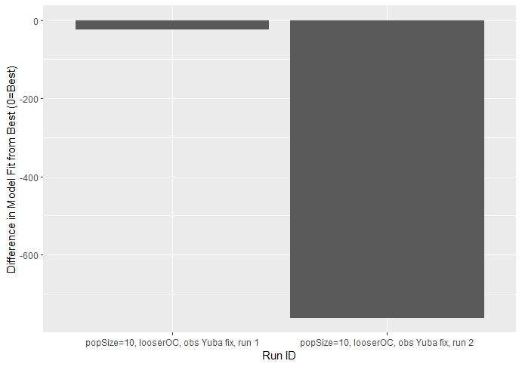

Figure 1. Comparison of differences in model fit for all sub-optimal models from the best model. The best model was *popSize=10, run=3* and had a model fit of -10,404.

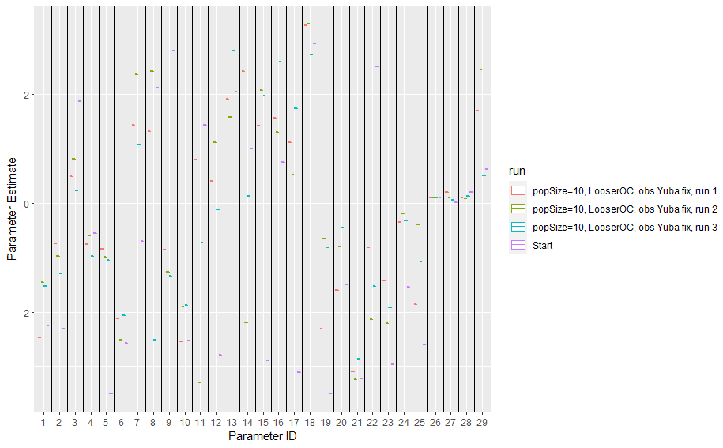

Figure 2. Plot of parameter estimates for 3 exploratory runs with popSize=10, as well the starting values drawn from the parameter values from the original calibration.

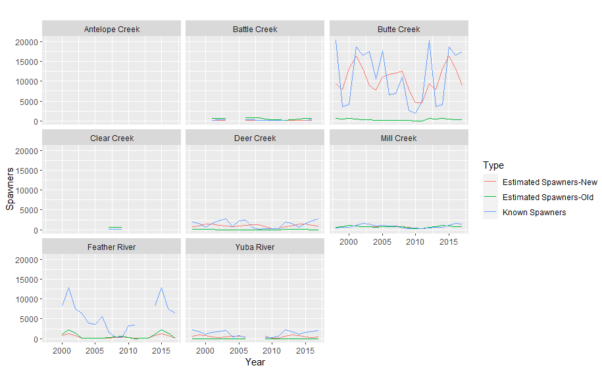

Figure 3. Plot of estimated spawners, both with original and newly calibrated parameter estimates, and known spawner abundances for the best preliminary calibration effort for spring-run Chinook salmon, presented for all watersheds that provided data to model calibration.

###### Final calibration, marine survival < 0.5

Reclamation conducted a final round of three calibration runs with a popSize=100 and marine survival constrained to be less than 0.5. From this final round of calibration runs, staff reached the following conclusions:

* The variability in metrics of model fit among model runs was similar to that observed for preliminary calibration runs with popSize=10 (Fig. 4).
* Staff observed reasonably consistent estimates for most parameters among the three calibration runs (Fig. 5). Logit-transformed estimates of marine survival for each watershed were broadly similar among runs. In contrast to model runs with popSize=10, estimates of marine survival did not run into either upper or lower bounds.
* Some parameters, notably parameter estimates for juvenile rearing survival in the San Joaquin River (parameter 8) and Delta (parameter 11) and migratory survival in the Sacramento River (parameter 15) were more variable among runs; migratory survival parameters can be expected to covary strongly because multiple covariate hypotheses are equally weighted for the Sacramento River.
* Staff selected the parameters from ‘run 3’ as the best model and generated model estimates of spawner abundance to compare with ‘known’ spawners (Figs. 6, 7). Model estimates of spawner abundance again appear to closely match observed spawner abundances from Butte Creek but more poorly reflect observed abundances from other systems. Estimates abundances were particularly biased low for Feather River and Yuba River. The correlation between all estimated and observed abundances for 1998-2011 was 0.763, which again compares favorably with the correlation of 0.8 reported in Peterson and Duarte (2020); staff note that this correlation was achieved without modifying habitat quantity scalars (i.e., artificially decreasing or increasing habitat quantity).
* Based on these results and the criteria for calibration success, Reclamation selected the parameters from ‘run 3’ as the new parameters for the spring-run DSM and applied these values to compare the effects of competing alternatives on the spring-run population. The parameter values are presented in Table 2.

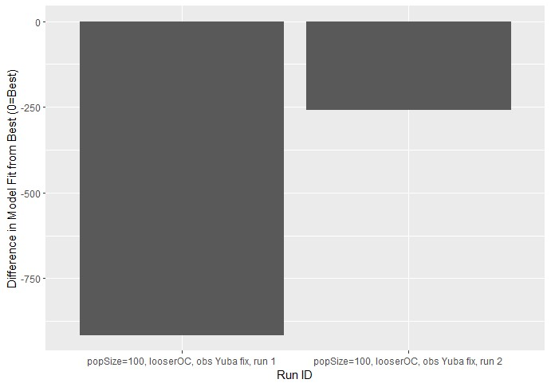

Figure 4. Comparison of differences in model fit for all sub-optimal models from the best model with *popSize=100*. The best model was *popSize=100, run=*3 and had a model fit of -9,981.

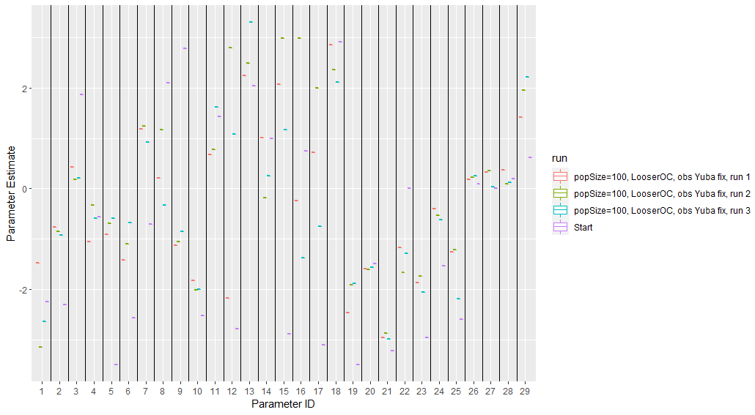

Figure 5. Plot of parameter estimates for 3 calibration runs with popSize=100, as well the starting values drawn from the parameter values from the original calibration.

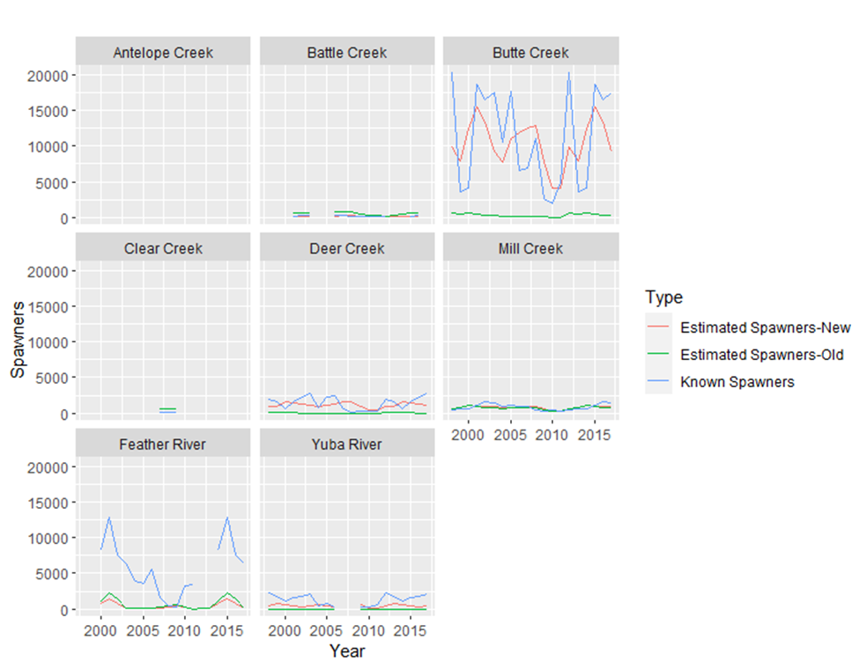

Figure 6. Plot of estimated spawners, both with original and newly calibrated parameter estimates, and known spawner abundances for the best final calibration effort for spring-run Chinook salmon, presented for all watersheds that provided data to model calibration.

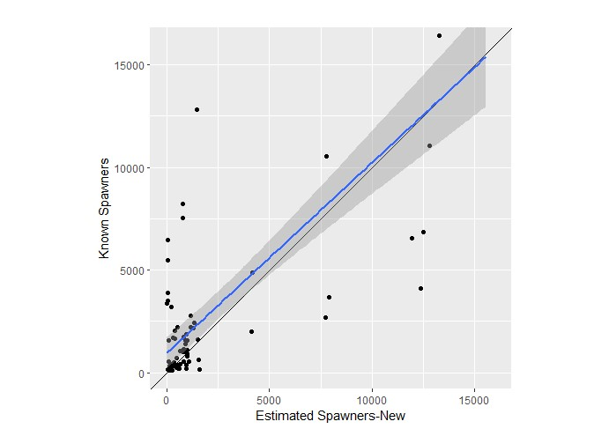

Figure 7. Scatterplot of estimated spring-run spawners with the newly calibrated parameter estimates and known spawner abundances for the selected parameter values from the final calibration efforts. A 1:1 line (black) is provided for reference, in addition to the fit of a linear regression to the scatterplot points (blue).

Table 2. Original and new parameter values for the spring-run DSM.

|  |  |  |  |
| --- | --- | --- | --- |
| **Parameter ID** | **Description** | **Original Calibration Value** | **New Calibration Value** |
| 1 | Juvenile in-channel and floodplain rearing survival intercept, Antelope Creek and other tributaries | -2.25 | -2.65 |
| 2 | Juvenile in-channel and floodplain rearing survival intercept, Deer Creek | -2.31 | -0.93 |
| 3 | Juvenile in-channel and floodplain rearing survival intercept, Mill Creek | 1.87 | 0.21 |
| 4 | Juvenile in-channel and floodplain rearing survival intercept, Feather River | -0.55 | -0.59 |
| 5 | Juvenile in-channel and floodplain rearing survival intercept, Yuba River | -3.5 | -0.60 |
| 6 | Juvenile in-channel and floodplain rearing survival intercept, Upper-mid/ Lower-mid/Lower Sacramento River | -2.57 | -0.67 |
| 7 | Juvenile in-channel and floodplain rearing survival intercept, Butte Creek | -0.71 | 0.93 |
| 8 | Juvenile in-channel and floodplain rearing survival intercept, San Joaquin River | 2.1 | -0.32 |
| 9 | Juvenile in-channel and floodplain rearing survival intercept, Battle, Clear Creek | 2.79 | -0.85 |
| 10 | Juvenile bypass rearing survival intercept | -2.52 | -2.00 |
| 11 | Juvenile Delta rearing survival intercept | 1.43 | 1.62 |
| 12 | Juvenile San Joaquin migratory survival intercept | -2.79 | 1.08 |
| 13 | Juvenile Sacramento River migratory survival intercept (discharge model) | 2.04 | 3.31 |
| 14 | Juvenile Sacramento River migratory survival intercept (temperature model) | 1 | 0.26 |
| 15 | Juvenile Delta migratory survival intercept (flow model) | -2.89 | 1.17 |
| 16 | Juvenile Delta migratory survival intercept (temperature model) | 0.75 | -1.37 |
| 17 | Juvenile Delta migratory survival intercept (diversion model) | -3.1 | -0.75 |
| 18 | Adult en route survival intercept | 2.92 | 2.12 |
| 19 | Juvenile ocean entry survival intercept - Antelope Creek and other tributaries | -3.5 | -1.88 |
| 20 | Juvenile ocean entry survival intercept - Deer Creek | -1.5 | -1.56 |
| 21 | Juvenile ocean entry survival intercept – Mill Creek | -3.23 | -3.00 |
| 22 | Juvenile ocean entry survival intercept – Feather, Bear River | 2.5 | -1.29 |
| 23 | Juvenile ocean entry survival intercept – Yuba River | -2.96 | -2.06 |
| 24 | Juvenile ocean entry survival intercept – Butte Creek | -1.54 | -0.62 |
| 25 | Juvenile ocean entry survival intercept – Battle, Clear Creek | -2.59 | -2.19 |
| 26 | Effect of contact points on juvenile rearing survival | 0.1 | 0.26 |
| 27 | Effect of proportion flow diverted on juvenile rearing/migratory survival | 0.01 | 0.03 |
| 28 | Effect of total flow diverted on juvenile rearing/migratory survival | 0.19 | 0.12 |
| 29 | Effect of Delta diversions on juvenile rearing survival | 0.61 | 2.22 |

#### Assumptions related to model structure and parameterization

There are numerous additional model assumptions that bear mentioning. First, to seed the starting number of returning adults from the ocean (i.e., necessary to calculate numbers of returning spawners), the model is run for 5 preliminary years using a fixed number of spawners in each of those five years for focal watersheds (i.e., Antelope Creek=4, Battle Creek=440, Butte Creek=8897, Clear Creek=180, Deer Creek=575, Mill Creek=479, Feather River=4812, Yuba River=642), as well as original CalSim II-based flow inputs for the first five years of the simulated time period. Additionally, in each of the 20 tracked model years, a specified number of hatchery fish is allocated among watersheds based on past CWT reports; this number is either 6036 if the model is run deterministically or a randomly selected number based on the uniform distribution bounded by 5489 and 8690 if the model is run stochastically. Proportional allocations of hatchery fish are as follows: Antelope Creek=0.01%, Battle Creek=0.45%, Big Chico Creek=0.08%, Butte Creek=0.29%, Clear Creek=0.04%, Cottonwood Creek=0.01%, Deer Creek=0.54%, Feather River=86.53%, Yuba River=12.07%.

Additionally, some demographic rates are not constructed to vary as a function of changing flow and temperature inputs in this model version, despite potential expectations to the contrary; an incomplete list of examples is provided below:

* Timing of adult arrival to the spawning grounds and subsequent spawning
* Egg-to-fry survival
  + - Egg-to-fry survival is estimated as a function of the annual proportion of natural-origin spawners for each watershed and constant watershed-specific effects of temperature and scour
    - Neither temperature nor scour effects are constructed to be responsive to model estimates of flow or temperature from CalSim or HEC-5Q models, respectively
* Juvenile growth rates

Finally, Reclamation staff note that that expected spawner abundances from model runs with and without stochasticity (i.e., stochastic and deterministic model runs) sometimes differ due to asymmetrical effects of adding variability. Specifically, stochasticity in model parameters (e.g., rearing survival) is implemented by drawing covariate effects from a statistical distribution (e.g., the effect of stranding is drawn from a Bernoulli distribution, in which the expected proportion of the population affected by stranding is the probability of stranding occurrence) and then obtaining parameter estimates by conducting inverse-logit transformations of these effect values. In isolation, drawing covariate effects from statistical distributions should produce variable but unbiased parameters relative the deterministic parameters. However, drawing covariate effects from statistical distributions and then applying non-linear transformations biases the expected values of the stochastic parameters relative to deterministic values, and can subsequently change expected spawner abundances. This phenomenon is documented in the R script, ‘Proof of Biased Parameters with Stochasticity and Inverse-Logit Transformations.R’.

#### Assumptions related to construction of new flow inputs

Reclamation constructed new model inputs for flow using updated results from new CalSim 3 runs for each scenario. Using a combination of R annotation associated with the cvpiaData package, R scripts shared from the cvpiaFlow GitHub repository, and discussions with CalSim modelers, Reclamation generated all the model flow inputs using updated CalSim 3 results by pulling directly from the raw .dss output files. We note that updating flow inputs using CalSim 3 runs was markedly more complex than using CalSim II runs, as CalSim 3 operates under different assumptions and at a finer resolution than CalSim II.

The following flow variables used by the DSMs were updated with data from alternative-specific CalSim 3 runs:

* Monthly flows, variability in flow, and proportion of natal flow (relative to larger watersheds) for each of 31 watersheds in the Sacramento-San Joaquin River basin
* Monthly flows at Freeport, Vernalis, and Stockton
* Monthly total exports from the Central Valley Project and State Water Project
* Diverted flows in each of the 31 watersheds in the Sacramento-San-Joaquin River basin (expressed both as total diversions and diversions relative to total flow)
* Proportion of Sacramento River flow into the Sutter and Yolo Bypasses
* Indications for whether gates downstream of Sutter and Yolo Bypasses are overtopped
* Monthly operations of the Delta Cross Channel gates
* Inflow into the North and South Delta
* Diverted flows in the North and South Delta (expressed both as total diversions and diversions relative to inflow)

Reclamation conducted internal validation to ensure updates to flow inputs using new CalSim 3 runs did not result in unexpectedly large changes in flow values (i.e., resulting from user error). For each of the above inputs to the DSMs, staff visualized and compared input values among the original DSM inputs and those based on the LTO NAA alternative. Reclamation did not find any issues except where there was not 1:1 matching between CalSim II and CalSim 3 nodes. Input diagnostic plots are available for review in the cvpiaFlow shared Code and Data repository.

The following demographic parameters are expected to be influenced by the updated flow inputs based on CalSim 3 runs reflecting LTO alternatives:

* Adult straying rates among spawning tributaries (spring-run only)
* Adult en route survival
* Juvenile river rearing survival
* Juvenile movement as a function of pulse flows
* Juvenile river migratory survival
* Juvenile entrainment into the South Delta from the Sacramento River
* Juvenile routing and survival in the South Delta, following entrainment
* Juvenile routing and survival in the North Delta

Reclamation also changed the implementation of the flow input for the number of days the Delta Cross Channel is closed each month. In the published model, this input is based on prescribed operations from the 2009 NMFS BiOp, with no interannual variability. Reclamation currently has access to a CalSim 3 node that provides estimated gate operations for each month and year in the model time series, and therefore modified this variable in LTO analyses to use expected month- and year-specific operations from alternative-specific CalSim 3 runs.

There was another potential inconsistency between model documentation and model implementation that needed to be addressed while updating flow inputs. Model documentation, as interpreted by Reclamation, suggested multiple CalSim II diversion variables may be used when calculating proportion of Sacramento River flow diverted into the Sutter Bypass (D117, D124, D125, D126), but only one diversion term that only infrequently exceeds 0 cfs was used in the original R code that produced the final model input (D117). Due to uncertainty in the intent of this flow input (i.e., whether the higher or lower diversion flow should be used), staff retained the previously implemented diversion calculation. Therefore, differences in the neglected diversion terms among LTO alternatives will not translate to different model outcomes.

Reclamation staff again emphasize that updating flow inputs using CalSim 3 runs was markedly more complex than using CalSim II runs, as CalSim 3 operates under different assumptions and at a finer resolution than CalSim II. Extensive modifications and numerous judgment calls were required with these modifications, and the conversions were made in close consultation with the Bureau of Reclamation Bay-Delta Office’s Modeling Division, which is partly responsible for developing and applying CalSim 3 (C. Koizumi, personal comm.). The conversions from CalSim II to CalSim 3 for all updated flow inputs to the v2019 SIT DSMs (i.e., Peterson and Duarte 2020) are summarized in the sections below, in which each section is a different data object, typically contained within the repositories cvpiaData ([FlowWest/cvpiaData (github.com)](https://github.com/FlowWest/cvpiaData)) or cvpiaFlow ([FlowWest/cvpiaFlow: Flow Data for use with CVPIA SIT DSM (github.com)](https://github.com/FlowWest/cvpiaFlow)). For additional details, refer to the R script ‘DSS workflow_cvpiaFlow_clean_CalSim3.R’, which generates modified data inputs to the SIT DSM from raw CalSim 3 outputs, or the supplemental Excel file ‘CalSim Mapping Document_2.28.23.xlsx’, which presents expected relationships between individual CalSim II and CalSim 3 variables, in the Code and Data repository. If inputs are not listed or described here, no change was required going from CalSim II to 3. Reclamation recommends future model users interested in running these models with new CalSim 3 runs carefully examine and revise, as necessary, the model documentation and annotation.

##### *dlt_divers_tot*: Total diverted of delta inflow in cms from 1980-2000.

The following is a comparison of CalSim II and CalSim 3 variables and calculations for total diversions in the North and South Delta. For example, variables proceeded by ‘D’ and ‘C’ typically indicate diversion- and flow-based terms, with proceeding numbers and letters reflecting different locations or processes.

* CalSim II:
  + North Delta: D403A + D403B + D403C + D403D + D404
  + South Delta: D418 + D419 + D412 + D410 + D413 + D409B + D416 + D408_OR + D408_VC
* CalSim 3:
  + North Delta: C_CSL004B + DD_SAC017_SACS
  + South Delta: D_OMR028_DMC000 + D_OMR027_CAA000 + DD_SJR026_SJRE + DD_SJR013_SJRW + DD_MOK004_MOK + DD_OMR027_OMR + D_RSL004_CCC004 + D_OMR021_ORP000 + D_VCT002_ORP000
* Important caveats or concerns:
  + There is a meaningful difference in how North Delta diversions are handled between CalSim II and 3. Replacing D404 with DD_SAC017_SACS adds ~200 TAF annually due to differences in assumptions regarding consumptive use.

##### *dlt_inflow*: Delta inflow in cms from 1980-2000.

The following is a comparison of CalSim II and CalSim 3 variables and calculations for inflow to the North and South Delta.

* CalSim II:
  + North Delta: C400 + C157
  + South Delta: C401B + C504 + C508 + C644
* CalSim 3:
  + North Delta: C_SAC041 + C_CSL005
  + South Delta: C_SAC029B + D_SAC030_MOK014 + C_MOK022 + C_CLV004 + C_SJR056
* Important caveats or concerns:
  + None

The *dlt_inflow* and *dlt_divers_tot* objects are used in conjunction to calculate the *dlt_divers* object, which represents the proportion of Delta diversions relative to inflow.

##### *flows_cfs*: Average monthly flows in all 31 modeled watersheds from 1980-2000

* CalSim II:
  + Upper Sacramento River: C104
  + Antelope Creek: C11307
  + Battle Creek: C10803
  + Bear Creek: C11001
  + Big Chico Creek: C11501
  + Butte Creek: C217A
  + Clear Creek: C3
  + Cottonwood Creek: C10802
  + Cow Creek: C10801
  + Deer Creek: C11309
  + Elder Creek: C11303
  + Mill Creek: C11308
  + Paynes Creek: C11001
  + Stony Creek: C142A
  + Thomes Creek: C11304
  + Upper-mid Sacramento River: C115
  + Bear River: C285
  + Feather River: C203
  + Yuba River: C230
  + Lower-mid Sacramento River: C134*35.6/58 + C160*22.4/58
  + American River: C9
  + Lower Sacramento River: C166
  + Calaveras River: C92
  + Cosumnes River: C501
  + Mokelumne River: *NA*
  + Merced River: C561
  + Stanislaus River: C520
  + Tuolumne River: C540
  + San Joaquin River: C630
* CalSim 3:
  + Upper Sacramento River: C_SAC273
  + Antelope Creek: C_ANT010
  + Battle Creek: C_BTL006
  + Bear Creek: C_BCN005
  + Big Chico Creek: C_BCC004
  + Butte Creek: C_BTC012
  + Clear Creek: C_CLR009
  + Cottonwood Creek: C_CWD003
  + Cow Creek: C_COW003
  + Deer Creek: C_DRC005
  + Elder Creek: C_ELD005
  + Mill Creek: C_MLC004
  + Paynes Creek: C_PYN001
  + Stony Creek: C_STN004
  + Thomes Creek: C_THM005
  + Upper-mid Sacramento River: C_SAC193
  + Bear River: C_CMPFW
  + Feather River: C_FTR059
  + Yuba River: C_YUB002
  + Lower-mid Sacramento River: C_SAC093*35.6/58 + C_SAC048*22.4/58
  + American River: C_NTOMA
  + Lower Sacramento River: C_SAC063
  + Calaveras River: C_NHGAN
  + Cosumnes River: C_CSM005
  + Mokelumne River: C_CMCHE
  + Merced River: C_MCD050
  + Stanislaus River: C_STS059
  + Tuolumne River: C_TUO054
  + San Joaquin River: C_SJR081
* Important caveats or concerns:
  + In CalSim II, the same variable (C11001) previously included both Bear Creek and Paynes Creek. In Calsim 3, the two watersheds have unique flow values.
  + CalSim 3 includes flow values for the Mokelumne River.
  + For several tributaries near the Upper Sacramento River (e.g., Deer Creek, Thomes Creek, Antelope Creek, Mill Creek, Big Chico Creek, Cow Creek, Cottonwood Creek, Battle Creek), there are new Surface Runoff terms included in CalSim 3 that are not present in CalSim II and could influence flow values.

The *flows_cfs* object is used to calculate both the expected intra-annual variability in flow, or *prop.pulse* (i.e., as a proxy for pulse flow effects), and the flow signal for returning adults as a determinant of straying rates, or *returnQ*.

##### *upsac_flow*: Flow at Bend Bridge in cms from 1980-2000.

* CalSim II:
  + C109
* CalSim 3:
  + C_SAC257
* Important caveats or concerns:
  + None

##### *freeportQcms*: Inflow at Freeport in cms from 1980-2000.

* CalSim II:
  + C400
* CalSim 3:
  + C_SAC041
* Important caveats or concerns:
  + None

##### *Q_vern*: Flow in cms at Vernalis from 1980-1999.

* CalSim II:
  + C639
* CalSim 3:
  + C_SJR070
* Important caveats or concerns:
  + None

##### *Q_stck*: Flow in cms at Stockton from 1980-1999.

* CalSim II:
  + C417A
* CalSim 3:
  + C_SJR053A
* Important caveats or concerns:
  + None

##### *CVP_exp*: Total exports for CVP in cms.

* CalSim II:
  + DEL_CVP_TOTAL
* CalSim 3:
  + DEL_CVP_TOTAL_N + DEL_CVP_TOTAL_s
* Important caveats or concerns:
  + Recommend replacing previous variables from both CalSim II and CalSim 3 with D418 (CalSim II) and D_OMR028_DMC000 (CalSim 3) to reflect realized diversions from the Jones pumping facility (C. Koizumi, personal comm.).

##### *SWP_exp*: Total exports for SWP in cms.

* CalSim II:
  + DEL_SWP_TOTAL
* CalSim 3:
  + DEL_SWP_PMI + DEL_SWP_PAG + DEL_SWP_PIN
* Important caveats or concerns:
  + Recommend replacing previous variables from both CalSim II and CalSim 3 with D419 (CalSim II) and D_OMR027_CAA000 (CalSim 3) to reflect realized diversions from the Banks pumping facility (C. Koizumi, personal comm.).

##### *prop_diversion*: Proportion of flow diverted for each watershed every month of every year in the simulation (1980-200).

* CalSim II:
  + Upper Sacramento River: D104 / C104
  + Antelope Creek: (C11307 / (C11307 + C11308 + C11309) * D11305) / C11307
  + Battle Creek: *NA*
  + Bear Creek: *NA*
  + Big Chico Creek: *NA*
  + Butte Creek: (C217B + D217) / (C217B + D217 + C217A)
  + Clear Creek: *NA*
  + Cottonwood Creek: *NA*
  + Cow Creek: *NA*
  + Deer Creek: (C11309 / (C11307 + C11308 + C11309) * D11305) / C11309
  + Elder Creek: (C11303 / (C11303 + C11304) * D11301) / C11303
  + Mill Creek: (C11308 / (C11307 + C11308 + C11309) * D11305) / C11308
  + Paynes Creek: *NA*
  + Stony Creek: D17301 / C41
  + Thomes Creek: (C11304 / (C11303 + C11304) * D11301) / C11304
  + Upper-mid Sacramento River: (D109 + D112 + D113A + D113B + D114 + D118 + D122A + D122B + D123 + D124A + D128_WTS + D128) / C110
  + Bear River: D285 / (C285 + D285)
  + Feather River: (D201 + D202 + D7A + D7B) / C6
  + Yuba River: D230 / (C230 + D230)
  + Lower-mid Sacramento River: (D129A + D134 + D162 + D165) / C128
  + American River: D302 / C9
  + Lower Sacramento River: (D167 + D168 + D168A_WTS) / C166
  + Calaveras River: (D506A + D506B + D506C + D507) / C92
  + Cosumnes River: *NA*
  + Mokelumne River: *NA*
  + Merced River: (D562 + D566) / C561
  + Stanislaus River: D528 / C520
  + Tuolumne River: D545 / C540
  + San Joaquin River: (D637 + D630B + D630A + D620B) / (D637 + D630B + D630A + D620B + C637)
* CalSim 3:
  + Upper Sacramento River: (D_SAC296_WTPFTH + D_SAC296_02_SA + D_SAC294_WTPBLV + D_SAC294_03_PA + D_SAC289_03_PA + D_SAC281_02_NA + D_SAC273_03_NA) / C_SAC273
  + Antelope Creek: D_ANT010_05_NA / C_ANT010
  + Battle Creek: *NA*
  + Bear Creek: *NA*
  + Big Chico Creek: *NA*
  + Butte Creek: (D_BTC045_ESL008 + D_BTC043_10_NA + D_BTC036_10_NA + DBTC012_09_SA2 + D_BTC012_CRK005) / (D_BTC045_ESL008 + D_BTC043_10_NA + D_BTC036_10_NA + DBTC012_09_SA2 + D_BTC012_CRK005 + C_BTC012)
  + Clear Creek: *NA*
  + Cottonwood Creek: *NA*
  + Cow Creek: *NA*
  + Deer Creek: (D_DRC010_05_NA + D_DRC005_05_NA) / C_DRC005
  + Elder Creek: D_ELD012_04_NA / C_ELD005
  + Mill Creek: D_MLC006_05_NA / C_MLC004
  + Paynes Creek: *NA*
  + Stony Creek: D_STN021_06_PA / C_STN026
  + Thomes Creek: D_THM012_04_NA / C_THM005
  + Upper-mid Sacramento River: (D_SAC240_TCC001 + D_SAC240_05_NA + D_SAC224_04_NA + D_SAC196_MTC000 + D_SAC185_08N_NA + D_SAC185_09_NA + D_SAC178_08N_SA1 + D_SAC162_09_SA2 + D_SAC159_08S_SA1 + D_SAC159_08N_SA1 + D_SAC146_08S_NA1 + D_SAC136_18_NA + D_SAC136_18_SA + D_SAC129_08S_NA2 + D_SAC122_19_SA) / C_SAC247
  + Bear River: D_BRR017_23_NA / C_CMPFW
  + Feather River: (D_THRMF_12_NU1 + D_THRMF_11_NU1 + D_THRMA_WEC000 + D_THRMA_RVC000 + D_THRMA_JBC000) / C_OROVL
  + Yuba River: D_YUB011_15S_NA2 / (D_YUB011_15S_NA2 + C_YUB002)
  + Lower-mid Sacramento River: (D_SAC121_08S_SA3 + D_SAC115_19_SA + D_SAC109_08S_SA3 + D_SAC109_19_SA + D_SAC099_19_SA + D_SAC091_19_SA + D_SAC083_21_SA + D_SAC082_22_SA1 + D_SAC081_21_NA + D_SAC078_22_SA1 + D_SAC075_22_NA + D_SAC074_21_SA + D_SAC065_WTPBTB) / C_SAC120
  + American River: D_AMR007_WTPFBN / C_NTOMA
  + Lower Sacramento River: (D_SAC050_FPT013 + D_SAC062_WTPSAC) / C_SAC120
  + Calaveras River: (D_LJC022_60S_PA1 + D_CLV037_CACWD + D_CLV026_60S_PA1 + D_CLV026_WTPWDH) / C_NHGAN
  + Cosumnes River: *NA*
  + Mokelumne River: (D_MOK050_60N_NA3 + D_MOK050_60N_NA5 + D_MOK039_60N_NA5 + D_MOK035_60N_NA4 + D_MOK035_60N_NU1 + D_MOK035_WTPDWS + D_MOK033_60N_NA5) / C_CMCHE
  + Merced River: (D_MC042_63_NA2 + D_MCD021_63_NA4) / C_MCD050
  + Stanislaus River: (D_STS030_61_NA4 + D_STS004_61_NA6) / C_STS059
  + Tuolumne River: (D_TUO047_61_NA3 + D_TUO047_62_NA4 + D_TUO015_61_NA3 + D_TUO015_62_NA4) / C_TUO054
  + San Joaquin River: (D_SJR062_50_PA1 + D_SJR090_71_NA2 + D_SJR081_61_NA5 + D_SJR116_72_NA1) / (D_SJR062_50_PA1 + D_SJR090_71_NA2 + D_SJR081_61_NA5 + D_SJR116_72_NA1 + C_SJR072)
* Important caveats or concerns:
  + Watersheds with *NA* are assumed to have no diversions.
  + Some of the diversion terms in CalSim II corresponded to ‘Depletion’ terms that have no direct analogue in Calsim 3 (i.e., Calsim 3 uses ‘Closure-Terms’ that aggregate both accretion and depletion influences). These flow variables are therefore not accounted for in the CalSim 3 conversion.
  + In CalSim II, diversions for Antelope Creek, Deer Creek, Elder Creek, Mill Creek, and Thomes Creek were calculated by partitioning aggregate, multi-watershed diversion terms based on watershed-specific flows. Some of these aggregate diversion terms also encompassed diversions from the Sacramento River. This partitioning is not necessary in CalSim 3 due to finer resolution in diversion terms.
  + CalSim 3 includes flow and diversion values for the Mokelumne River.
  + Reclamation used CalSim II diversion variables for the 4 watershed regions along the Sacramento River to identify functional splits among regions, and then identified CalSim 3 diversion terms for each region based on these splits.

The numerator for each watershed was used to calculate the total diversions for each watershed every month of every year, or *total_diversion*.

##### *bypass_prop_Q*: Proportion of Lower Sacramento River flow at each bypass weir.

* CalSim II:
  + Sutter Bypass: D117 / C116
  + Yolo Bypass: D160 / (D160 + C160)
* CalSim 3:
  + Sutter Bypass: (SP_SAC193_BTC003 + SP_SAC188_BTC003 + SP_SAC178_BTC003) / C_SAC195
  + Yolo Bypass: SP_SAC083_YBP037 / (SP_SAC083_YBP037 + C_SAC048)
* Notes:
  + A potentially better characterization of proportional flow diverted into the Sutter Bypass, and the characterization that is used in more recent versions of the SIT DSMs (e.g., v2021, v2023) is expressed in CalSim II and CalSim 3 as the following:
    - CalSim II: (D117 + D124 + D125 + D126) / C116
    - CalSim 3: (SP_SAC193_BTC003 + SP_SAC188_BTC003 + SP_SAC178_BTC003 + SP_SAC159_BTC003 + SP_SAC148_BTC003 + SP_SAC122_SBP021) / C_SAC195
  + The conversion of C116 to C_SAC195 in CalSim 3 represents the best judgment of the Modeling Division.

##### *bypass_over*: Binary (yes/no) monthly record of the bypasses over topped

* CalSim II:
  + Sutter Bypass: TRUE if (D117 + D124 + D125 + D126 + C137) >= 100
  + Yolo Bypass: TRUE if (D160 + C157) >= 100
* CalSim 3:
  + Sutter Bypass: TRUE if (SP_SAC193_BTC003 + SP_SAC188_BTC003 + SP_SAC178_BTC003 + SP_SAC159_BTC003 + SP_SAC148_BTC003 + SP_SAC122_SBP021 + C_SSL001) >= 100
  + Yolo Bypass: TRUE if (SP_SAC083_YBP037 + C_CSL005) >= 100
* Notes:
  + The conversion of C137 in CalSim II to a CalSim 3 equivalent is problematic, as CalSim 3 changes the number and nature of connections among the Sacramento River, Sutter Bypass, Feather River, and Butte Creek. In fact, the best proposed replacement variable (C_SSL001) results in constant overtopping of Sutter Bypass in the model with the current flow threshold of 100 cfs.
    - Modeling also questions why C137 is included in the flow threshold in the first place, as the diversions terms should be sufficient by themselves.

#### Assumptions related to construction of new temperature inputs

Reclamation generated new monthly temperature inputs using alternative-specific HEC-5Q model results, which in turn used alternative-specific CalSim 3 model results, for the following watersheds: Upper Sacramento River, Clear Creek, Cottonwood Creek. Temperature updates were restricted to these watersheds based the limited spatial coverage of HEC-5Q modeling to watersheds utilized by winter-run and spring-run Chinook salmon for spawning and rearing. Reclamation also observed that model documentation for the original HEC-5Q variables used in the Upper Sacramento River temperature inputs was inconsistent with their actual application in the published DSMs: specifically, temperature inputs for both Cottonwood Creek and the Upper Sacramento were reportedly derived from the same HEC-5Q variable, but actual inputs differed between watersheds without clear explanation. In light of this uncertainty, Reclamation used the average of monthly temperatures from the HEC-5Q variables corresponding to the Sacramento River just below Keswick Dam (BLW KESWICK) and at Red Bluff Diversion Dam (RED BLUFF DAM) to characterize expected temperature conditions in the Upper Sacramento River, the temperatures at the IGO node to characterize temperatures in Clear Creek, and temperatures at the COTTONWOOD CR node to characterize temperatures in Cottonwood Creek.

The following temperature inputs were updated with this modification:

* Monthly average temperature for the Upper Sacramento River, Clear Creek, and Cottonwood Creek
* Monthly degree day accumulation (i.e., the sum of daily average temperatures for each month) for the Upper Sacramento River, Clear Creek, and Cottonwood Creek

Reclamation conducted internal validation to ensure updates to temperature inputs using new HEC-5Q runs did not result in unexpectedly large changes in values (i.e., resulting from user error). For each of the above inputs to the DSMs, staff visualized and compared input values among the original DSM inputs and those based on the LTO NAA alternative. Reclamation observed generally similar ranges in temperature input values for the Upper Sacramento River and Clear Creek, albeit with lower extremes observed for the LTO NAA alternative relative to original DSM inputs, but a much more muted range of temperature values for the LTO NAA alternative in Cottonwood Creek. Input diagnostic plots are available for review in the cvpiaTemperature folder in the shared Code and Data repository.

The following demographic parameters are expected to be influenced by the updated temperature inputs:

* In-channel and floodplain juvenile rearing survival in the Upper Sacramento River
* Adult pre-spawn survival during holding in the Upper Sacramento River

#### Assumptions related to construction of new habitat inputs

Model habitat inputs for the Peterson and Duarte (2020) version of the DSMs were based on a combination of expert judgment and flow to habitat relationships specific to both watershed and run type. Due to the considerable complexity associated in updating these values using new CalSim runs, Reclamation left the base habitat inputs unchanged from the published version of the DSMs. However, Reclamation reset a vector of habitat modifiers (i.e., values used to adjust expected habitat quantities via multiplication) to values of one during recalibration of the DSM, such that habitat quantities were equal to those values based on expert judgment and flow alone. Original calibration efforts for the Peterson and Duarte (2020) models used calibration to obtain both parameter values and new habitat modifiers, but Reclamation staff achieved sufficient model fit without needing to secondarily modify habitat quantities.

#### Assumptions related to selection of habitat restoration strategies

Model users must select a habitat restoration scenario when running the SIT DSMs, including no action (i.e., availability of spawning and rearing habitat will decrease over time without intervention) or some form habitat restoration (i.e., select watersheds are prioritized for additions of spawning and/or rearing habitat). Reclamation staff ran all DSM models with the no action habitat restoration scenario to avoid any possible interactions between flow, temperature, and habitat differences.

### Code and Data Repository

All R scripts and model inputs necessary to re-calibrate and run the model, with the exception of the raw CalSim 3 .dss files (due to file size concerns), are available online on ICF SharePoint at: <https://icfonline.sharepoint.com/:f:/r/sites/EP/USBR_2021LTO/Public%20Draft%20Alternatives/Appendix%20F.%20Life%20Cycle%20Analyses%20Attachments/F.%20LCA%20CVPIA%20SIT%20LCM?csf=1&web=1&e=EPRuFf>.

## Results

The EIS results include comparisons among the No Action Alternative (NAA) and all other management alternatives (Alt1 – Alt4), including the Proposed Action (PA, or Alt2). The BA results include results for the NAA, the EXP1 and EXP3 baseline alternatives, and the PA.

### EIS

Results for the EIS are summarized in Tables 3-6 and Figures 8-21.

Predicted total and natural-origin-only spawner abundances in the Central Valley for the deterministic model runs generally fluctuated between 1980 and 1999. The population as a whole and in the Upper Sacramento River reached a low in the early 1980s and peaked in 1988, decreased until 1990 and then generally trended upward (Tables 3, 4; Figs. 8, 9). The Clear Creek natural spawner abundances peaked in 1980 and reached a low in 1990 (Fig. 8). The range of natural-origin spawner abundances across alternatives at the end of the time series was narrow, ranging from a low of 12,611 to a high of 12,724; over the entire time series predicted natural-origin-spawner abundances ranged from 7,529 to 14,517 (Table 4). The alternatives Alt1, Alt3, and Alt4 generally resulted in increased spawner abundances relative to NAA over the modeled time series (i.e., -0.4% to 1.5% differences relative to NAA for Alt1, 0.0% to 4.6% for Alt3, and -0.1% to 1.6% for Alt4; Table 4; Fig. 10). The four components of Alt2 generally resulted in small increases in spawner abundance over the time series (i.e., -0.5% to 3.0% differences relative to NAA). The greatest increases in natural-origin spawner abundance relative to NAA occurred between 1990 and 1995. Predicted natural-origin spawner abundances in the Central Valley varied more widely across stochastic model runs, from a low of approximately 0 to a high of approximately 100,000 spawners (Fig. 11).

For deterministic model runs, population change over time, defined by mean (i.e., geometric) lambda values (Nt/Nt+1), over the entire 1980-1999 time series was consistently at 1.01 across all alternatives (Table 5), and terminal lambda values (Nt=19/Nt=1) were consistently at 1.21 (Table 6). These values indicated that predicted spawner abundances increased over the course of the time series. Annual lambda values from deterministic model runs ranged from approximately 0.75 to 1.37 (Fig. 12). Critical water years had the highest mean annual lambdas (>=1.07), followed by Above Normal Years (>=1.04); Dry water years were the only WYT to produce an apparent decline in abundance, with a mean lambda less than 1 (Table 5). Reclamation staff note that spawner abundances in any given year (or water year type) reflect a multitude of influences over time (e.g., previous spawner abundances and rearing conditions), and not just flow and temperature conditions during the spawning year. Mean lambda values across stochastic model iterations ranged from approximately 0.96 to 1.11 (Fig. 13). Terminal lambda values from stochastic models ranged from approximately 0.5 to 7.5 (Fig. 14), suggesting most model runs resulted in expected population growth over the time series. For stochastic model runs, Dry water years had a lower mean lambda value than other water year type (Fig. 15).

Population trends may be explained by differences in life stage-specific demographic parameters. It is worth emphasizing again that the egg-to-fry survival life stage transition in the DSM is not sensitive to alternative-dependent flow or temperature values, and thus will be constant across alternatives. Across deterministic runs, monthly rearing survival for small juveniles (i.e., <42 mm) in the Upper Sacramento River varied from a low of approximately 0.016 to a high of approximately 0.022 (Fig. 16); rearing survival in the Upper Sacramento River also varied across months, peaking in December and January, and showing greater variation across water years in April and May. In Clear Creek, monthly rearing survival for small juveniles (i.e., <42 mm) and varied across deterministic runs from approximately 0.16 to 0.18; rearing survival in Clear Creek also varied across months, with greater survival in February-May and lower survival in November-January.

Model-estimated migratory survival for very large fish (i.e., smolt size, >110 mm) in the Upper-mid, Lower-mid, and Lower Sacramento River was very close to 1, with slight variations across months and water year types (WYTs) (Figs. 17-19). In the Upper-mid and Lower-mid, and Lower Sacramento River, expected survival was consistently highest in Wet years. Migratory survival for very large fish also varied across months and WYT in the North and South Delta (Figs. 20-21). Migratory survival often increased moving from a Critical to Dry to Above Normal to Wet WYT. In the North Delta, migratory survival was relatively high, ranging from approximately 0.90 – 0.935, and lower in the South Delta, ranging from 0.21 – 0.58. In the South Delta, expected migratory survival was greatest in February and March and lowest in November. With migratory survival in the mainstem Sacramento River and North Delta high across the alternatives, rearing survival in natal tributaries and migratory survival in the South Delta likely act as drivers of lambda.

#### Population abundance, trends

Table 3. Predicted annual total spring-run spawner abundance in the Central Valley, including both natural- and hatchery-origin fish, from deterministic model runs. Parentheses indicate percent difference from NAA (negative values indicate a decrease in annual spawner abundance).

| Year | NAA | Alt1 | Alt2 wTUCP woVA | Alt2 woTUCP woVA | Alt2 woTUCP DeltaVA | Alt2 woTUCP AllVA | Alt3 | Alt4 |
| --- | --- | --- | --- | --- | --- | --- | --- | --- |
| 1980 | 14888 | 14882 (0.0) | 14889 (0.0) | 14889 (0.0) | 14888 (0.0) | 14888 (0.0) | 14890 (0.0) | 14889 (0.0) |
| 1981 | 13045 | 13048 (0.0) | 13046 (0.0) | 13046 (0.0) | 13046 (0.0) | 13046 (0.0) | 13043 (0.0) | 13046 (0.0) |
| 1982 | 13095 | 13118 (0.2) | 13097 (0.0) | 13097 (0.0) | 13108 (0.1) | 13134 (0.3) | 13114 (0.1) | 13099 (0.0) |
| 1983 | 15807 | 15867 (0.4) | 15817 (0.1) | 15817 (0.1) | 15836 (0.2) | 15884 (0.5) | 15888 (0.5) | 15822 (0.1) |
| 1984 | 15748 | 15788 (0.3) | 15758 (0.1) | 15758 (0.1) | 15764 (0.1) | 15776 (0.2) | 15823 (0.5) | 15760 (0.1) |
| 1985 | 14598 | 14609 (0.1) | 14601 (0.0) | 14601 (0.0) | 14600 (0.0) | 14593 (0.0) | 14660 (0.4) | 14603 (0.0) |
| 1986 | 12859 | 12860 (0.0) | 12857 (0.0) | 12857 (0.0) | 12852 (-0.1) | 12861 (0.0) | 12917 (0.5) | 12856 (0.0) |
| 1987 | 14295 | 14325 (0.2) | 14318 (0.2) | 14317 (0.2) | 14312 (0.1) | 14354 (0.4) | 14434 (1.0) | 14320 (0.2) |
| 1988 | 19578 | 19605 (0.1) | 19638 (0.3) | 19638 (0.3) | 19640 (0.3) | 19712 (0.7) | 19850 (1.4) | 19639 (0.3) |
| 1989 | 18233 | 18176 (-0.3) | 18275 (0.2) | 18276 (0.2) | 18283 (0.3) | 18353 (0.7) | 18452 (1.2) | 18274 (0.2) |
| 1990 | 13540 | 13512 (-0.2) | 13556 (0.1) | 13557 (0.1) | 13579 (0.3) | 13604 (0.5) | 13631 (0.7) | 13575 (0.3) |
| 1991 | 13973 | 14029 (0.4) | 14025 (0.4) | 14027 (0.4) | 14070 (0.7) | 14082 (0.8) | 14210 (1.7) | 14072 (0.7) |
| 1992 | 15275 | 15379 (0.7) | 15427 (1.0) | 15477 (1.3) | 15465 (1.2) | 15530 (1.7) | 15731 (3.0) | 15432 (1.0) |
| 1993 | 16087 | 16256 (1.1) | 16272 (1.2) | 16413 (2.0) | 16301 (1.3) | 16376 (1.8) | 16459 (2.3) | 16232 (0.9) |
| 1994 | 18042 | 18148 (0.6) | 18126 (0.5) | 18220 (1.0) | 18101 (0.3) | 18142 (0.6) | 18209 (0.9) | 18108 (0.4) |
| 1995 | 16889 | 16874 (-0.1) | 16890 (0.0) | 16859 (-0.2) | 16827 (-0.4) | 16859 (-0.2) | 16995 (0.6) | 16892 (0.0) |
| 1996 | 14759 | 14726 (-0.2) | 14764 (0.0) | 14726 (-0.2) | 14728 (-0.2) | 14760 (0.0) | 14871 (0.8) | 14759 (0.0) |
| 1997 | 18116 | 18135 (0.1) | 18119 (0.0) | 18123 (0.0) | 18115 (0.0) | 18127 (0.1) | 18249 (0.7) | 18117 (0.0) |
| 1998 | 19405 | 19435 (0.2) | 19397 (0.0) | 19400 (0.0) | 19399 (0.0) | 19397 (0.0) | 19547 (0.7) | 19397 (0.0) |
| 1999 | 17937 | 17934 (0.0) | 17937 (0.0) | 17937 (0.0) | 17940 (0.0) | 17939 (0.0) | 18048 (0.6) | 17937 (0.0) |

Table 4. Predicted annual natural-origin spring-run spawner abundance in the Central Valley from deterministic model runs. Parentheses indicate percent difference from NAA (negative values indicate a decrease in annual spawner abundance).

| Year | NAA | Alt1 | Alt2 wTUCP woVA | Alt2 woTUCP woVA | Alt2 woTUCP DeltaVA | Alt2 woTUCP AllVA | Alt3 | Alt4 |
| --- | --- | --- | --- | --- | --- | --- | --- | --- |
| 1980 | 9562 | 9557 (-0.1) | 9566 (0.0) | 9566 (0.0) | 9562 (0.0) | 9563 (0.0) | 9566 (0.0) | 9566 (0.0) |
| 1981 | 7713 | 7714 (0.0) | 7713 (0.0) | 7713 (0.0) | 7714 (0.0) | 7713 (0.0) | 7711 (0.0) | 7713 (0.0) |
| 1982 | 7773 | 7796 (0.3) | 7776 (0.0) | 7776 (0.0) | 7786 (0.2) | 7810 (0.5) | 7792 (0.2) | 7778 (0.1) |
| 1983 | 10483 | 10544 (0.6) | 10495 (0.1) | 10494 (0.1) | 10515 (0.3) | 10563 (0.8) | 10564 (0.8) | 10501 (0.2) |
| 1984 | 10424 | 10465 (0.4) | 10433 (0.1) | 10433 (0.1) | 10438 (0.3) | 10451 (0.3) | 10498 (0.7) | 10435 (0.1) |
| 1985 | 9263 | 9275 (0.1) | 9268 (0.1) | 9268 (0.1) | 9265 (0.0) | 9260 (0.0) | 9329 (0.7) | 9269 (0.1) |
| 1986 | 7536 | 7539 (0.0) | 7532 (-0.1) | 7533 (0.0) | 7529 (-0.1) | 7538 (0.0) | 7595 (0.8) | 7532 (-0.1) |
| 1987 | 8961 | 8991 (0.3) | 8985 (0.3) | 8985 (0.3) | 8978 (0.2) | 9020 (0.7) | 9102 (1.6) | 8985 (0.3) |
| 1988 | 14247 | 14272 (0.2) | 14305 (0.4) | 14305 (0.4) | 14306 (0.4) | 14379 (0.9) | 14517 (1.9) | 14307 (0.4) |
| 1989 | 12898 | 12843 (-0.4) | 12941 (0.3) | 12942 (0.3) | 12949 (0.4) | 13018 (0.9) | 13119 (1.7) | 12940 (0.3) |
| 1990 | 8210 | 8182 (-0.3) | 8226 (0.2) | 8226 (0.2) | 8249 (0.5) | 8276 (0.8) | 8301 (1.1) | 8244 (0.4) |
| 1991 | 8639 | 8695 (0.7) | 8693 (0.6) | 8695 (0.7) | 8735 (1.1) | 8748 (1.3) | 8874 (2.7) | 8739 (1.2) |
| 1992 | 9941 | 10047 (1.1) | 10096 (1.6) | 10144 (2.0) | 10133 (1.9) | 10195 (2.6) | 10399 (4.6) | 10100 (1.6) |
| 1993 | 10764 | 10930 (1.5) | 10948 (1.7) | 11090 (3.0) | 10977 (2.0) | 11053 (2.7) | 11134 (3.4) | 10906 (1.3) |
| 1994 | 12707 | 12816 (0.9) | 12792 (0.7) | 12887 (1.4) | 12769 (0.5) | 12808 (0.8) | 12876 (1.3) | 12775 (0.5) |
| 1995 | 11564 | 11550 (-0.1) | 11565 (0.0) | 11534 (-0.3) | 11504 (-0.5) | 11537 (-0.2) | 11673 (0.9) | 11566 (0.0) |
| 1996 | 9436 | 9405 (-0.3) | 9442 (0.1) | 9403 (-0.4) | 9407 (-0.3) | 9439 (0.0) | 9548 (1.2) | 9439 (0.0) |
| 1997 | 12791 | 12811 (0.2) | 12795 (0.0) | 12796 (0.0) | 12791 (0.0) | 12803 (0.1) | 12924 (1.0) | 12792 (0.0) |
| 1998 | 14081 | 14110 (0.2) | 14076 (0.0) | 14078 (0.0) | 14076 (0.0) | 14075 (0.0) | 14222 (1.0) | 14077 (0.0) |
| 1999 | 12613 | 12611 (0.0) | 12613 (0.0) | 12615 (0.0) | 12615 (0.0) | 12614 (0.0) | 12724 (0.9) | 12615 (0.0) |

Table 5. Predicted mean lambda (Nt/Nt+1) for total spring-run spawner abundance in the Central Valley, including both natural- and hatchery-origin fish, from deterministic model runs. Parentheses indicate percent difference from NAA (negative values indicate a decrease in annual spawner abundance).

| WYT | NAA | Alt1 | Alt2 wTUCP woVA | Alt2 woTUCP woVA | Alt2 woTUCP DeltaVA | Alt2 woTUCP AllVA | Alt3 | Alt4 |
| --- | --- | --- | --- | --- | --- | --- | --- | --- |
| C | 1.072 | 1.072 (0.07) | 1.072 (0.0) | 1.072 (0.0) | 1.072 (0.0) | 1.072 (0.0) | 1.074 (0.2) | 1.073 (0.1) |
| D | 0.962 | 0.961 (-0.09) | 0.962 (0.0) | 0.962 (0.0) | 0.962 (0.0) | 0.962 (0.1) | 0.962 (0.1) | 0.962 (0.0) |
| AN | 1.053 | 1.057 (0.4) | 1.055 (0.2) | 1.060 (0.7) | 1.054 (0.1) | 1.054 (0.1) | 1.047 (-0.6) | 1.052 (-0.1) |
| W | 1.013 | 1.013 (-0.03) | 1.013 (0.0) | 1.013 (-0.1) | 1.013 (0.0) | 1.013 (0.0) | 1.014 (0.0) | 1.013 (0.0) |
| All | 1.010 | 1.010 (0.0) | 1.010 (0.0) | 1.010 (0.0) | 1.010 (0.0) | 1.010 (0.0) | 1.010 (0.0) | 1.010 (0.0) |

Table 6. Predicted terminal lambda (Nt=19/Nt=1) for total spring-run spawner abundance in the Central Valley, including both natural- and hatchery-origin fish, from deterministic model runs. Parentheses indicate percent difference from NAA (negative values indicate a decrease in annual spawner abundance).

| NAA | Alt1 | Alt2 wTUCP woVA | Alt2 woTUCP woVA | Alt2 woTUCP DeltaVA | Alt2 woTUCP AllVA | Alt3 | Alt4 |
| --- | --- | --- | --- | --- | --- | --- | --- |
| 1.21 | 1.21 (0.0) | 1.21 (0.0) | 1.21 (0.0) | 1.21 (0.0) | 1.21 (0.0) | 1.21 (0.6) | 1.21 (0.0) |

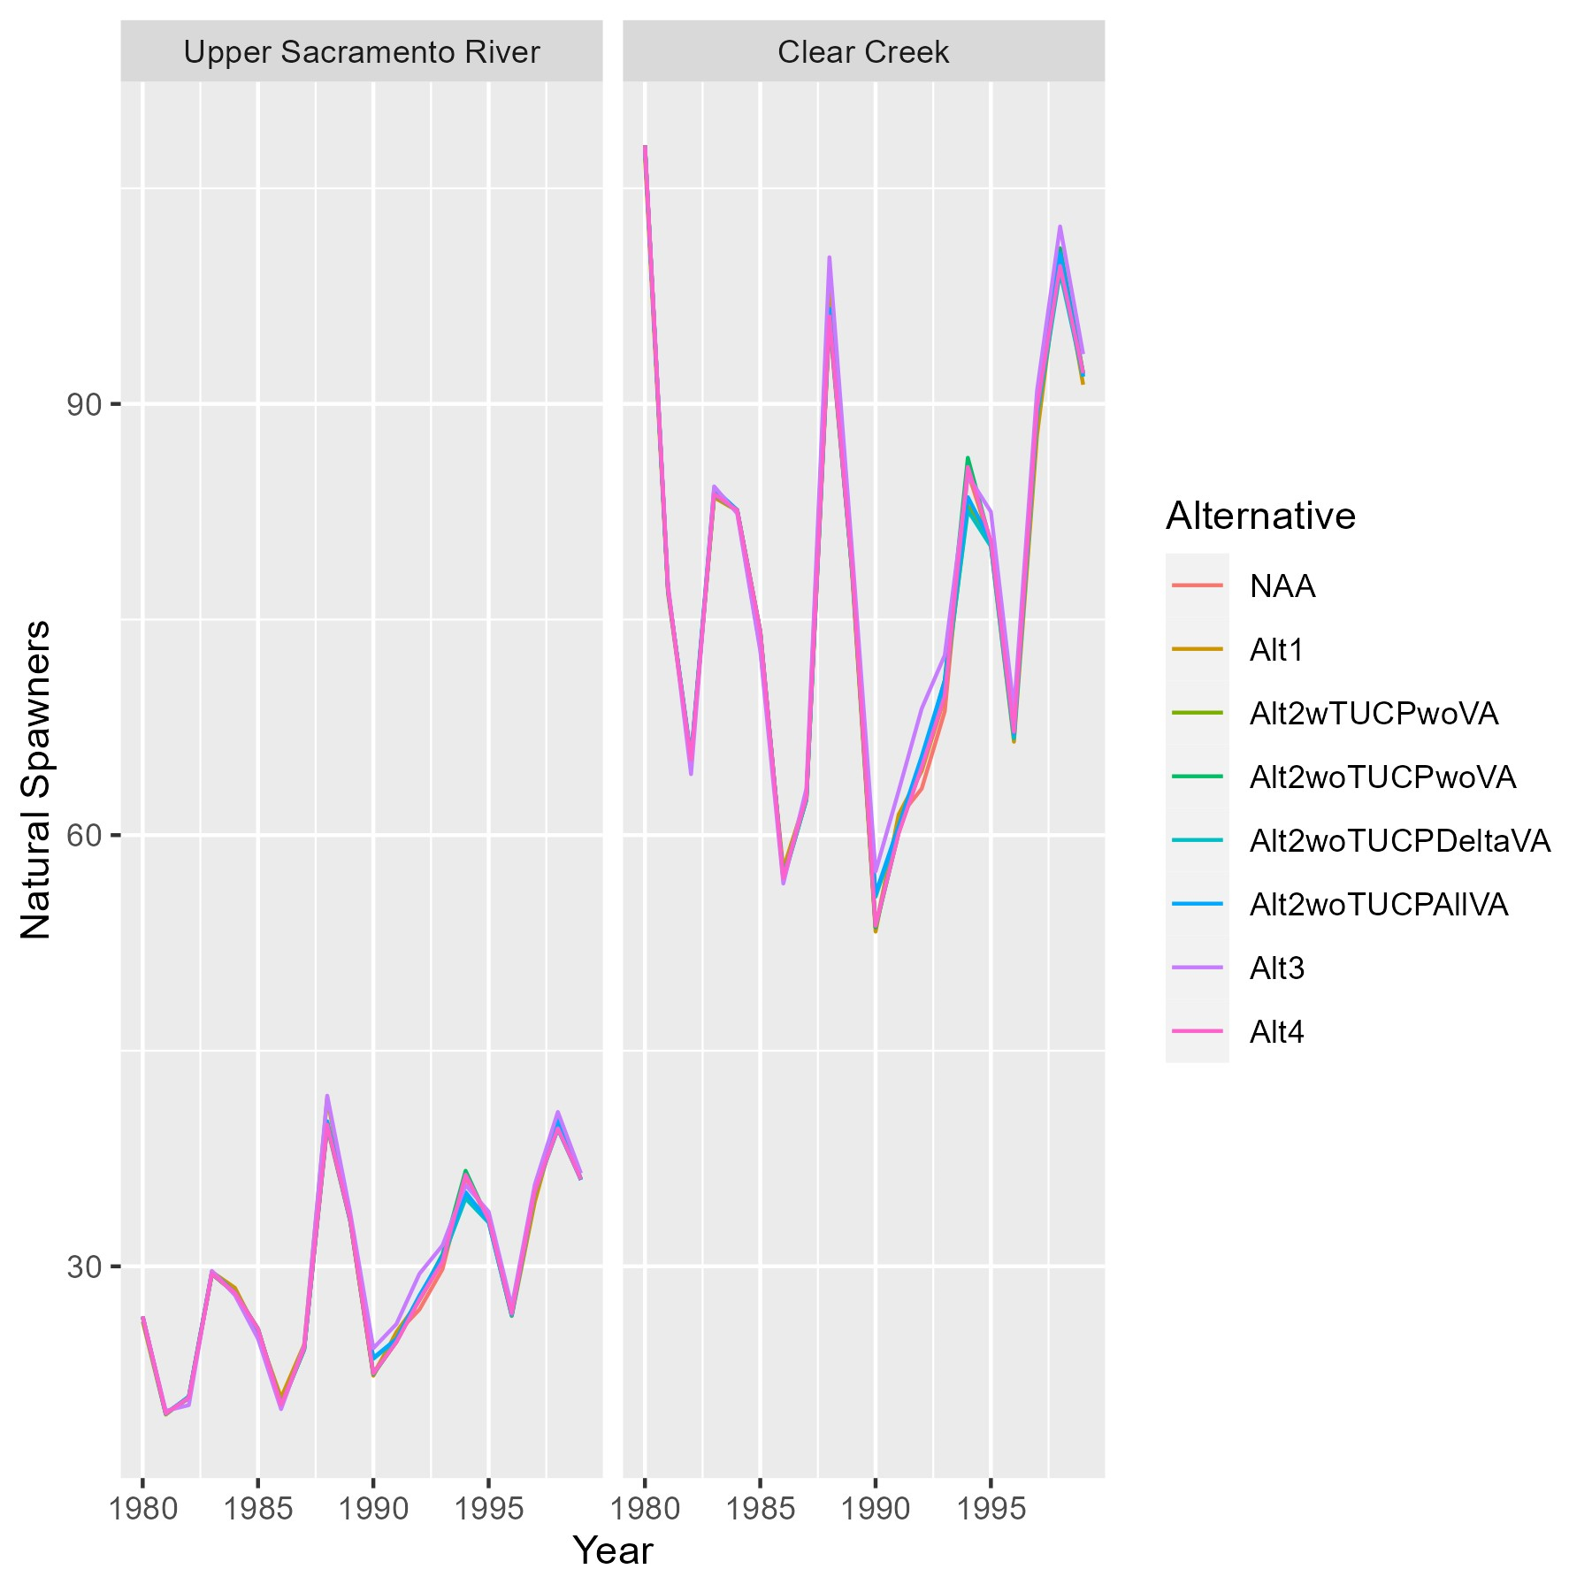

Figure 8. Expected annual abundances of natural-origin spring-run Chinook salmon spawners in the Upper Sacramento River and Clear Creek from deterministic model runs.

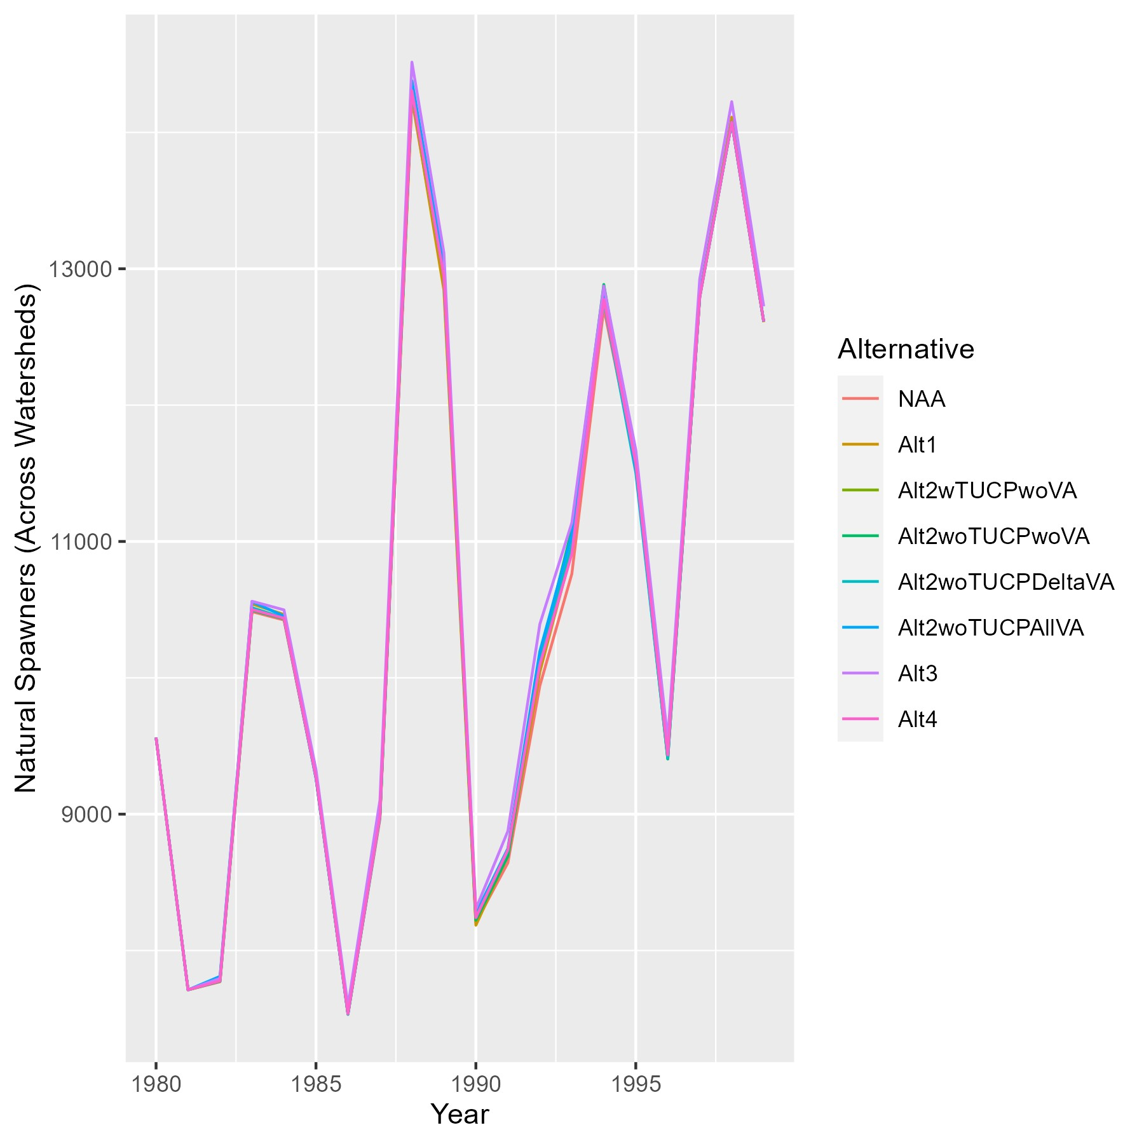

Figure 9. Expected annual abundances of natural-origin spring-run Chinook salmon spawners in the Central Valley from deterministic model runs.

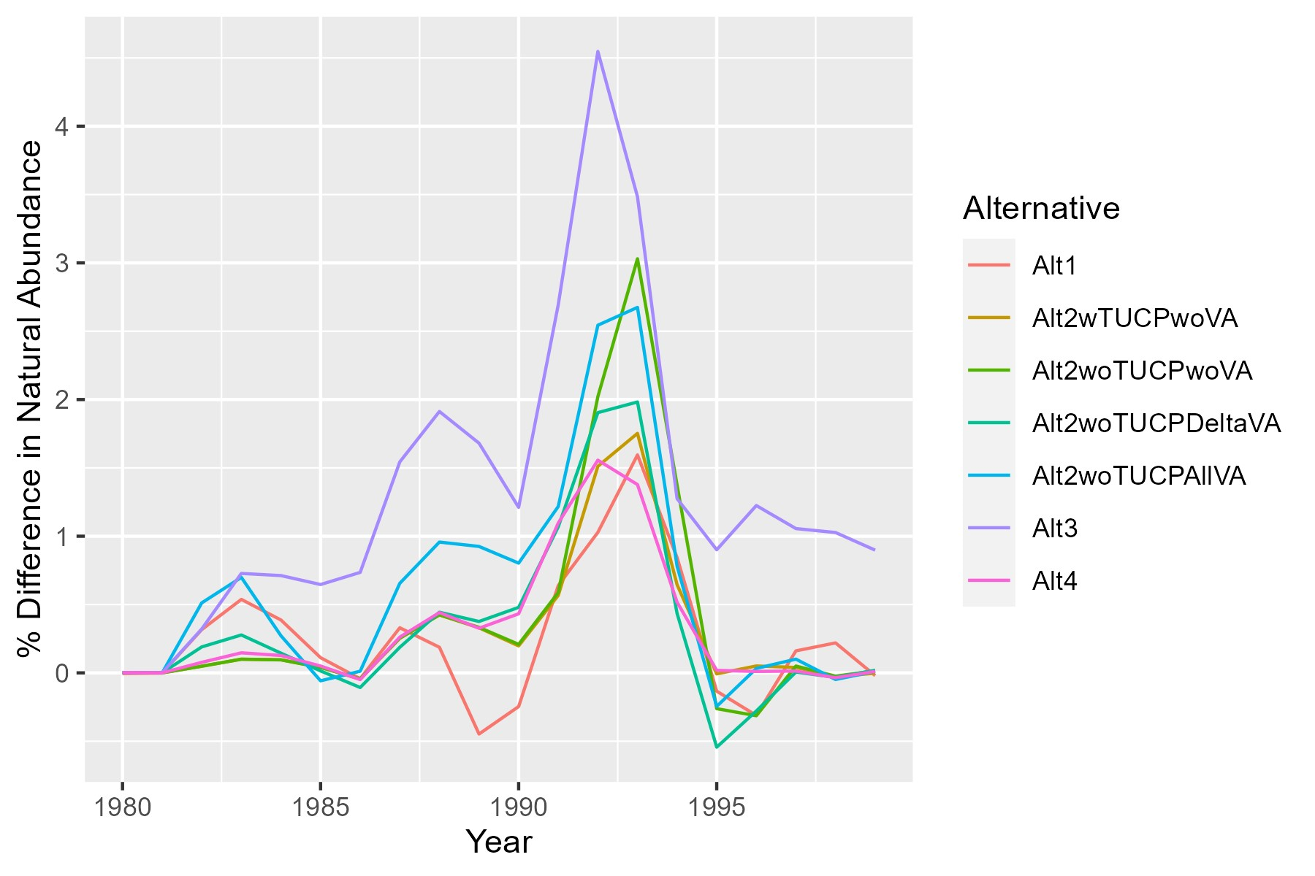

Figure 10. Expected percent differences in annual abundances of natural-origin spring-run Chinook salmon spawners in the Central Valley, relative to the NAA alternative, from deterministic model runs.

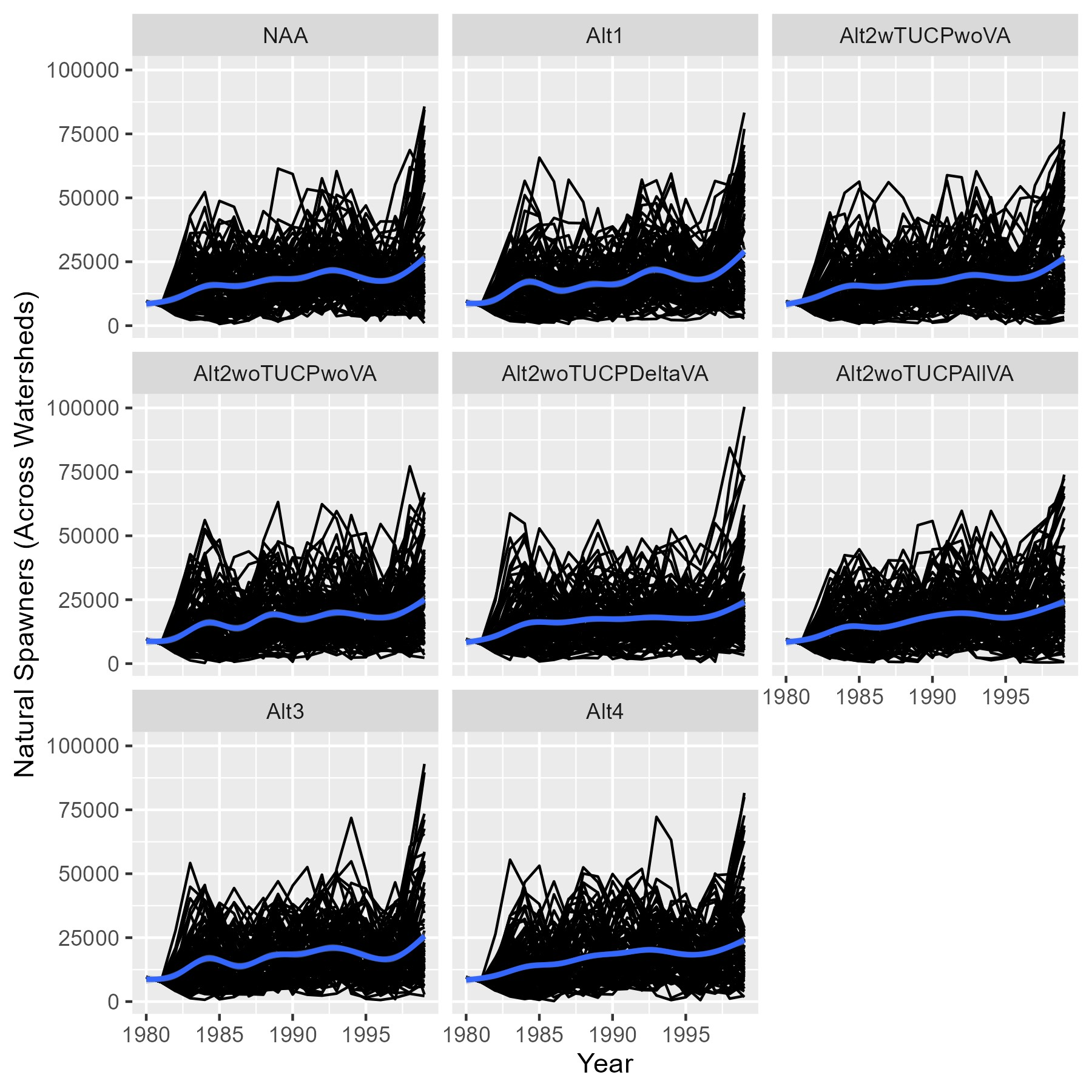

Figure 11. Expected annual abundances of natural-origin spring-run Chinook salmon spawners in the Central Valley from stochastic model runs. Black lines represent iteration-specific abundances over time and the blue line represents an expected trend obtained by ‘gam’ smoothing in ggplot2.

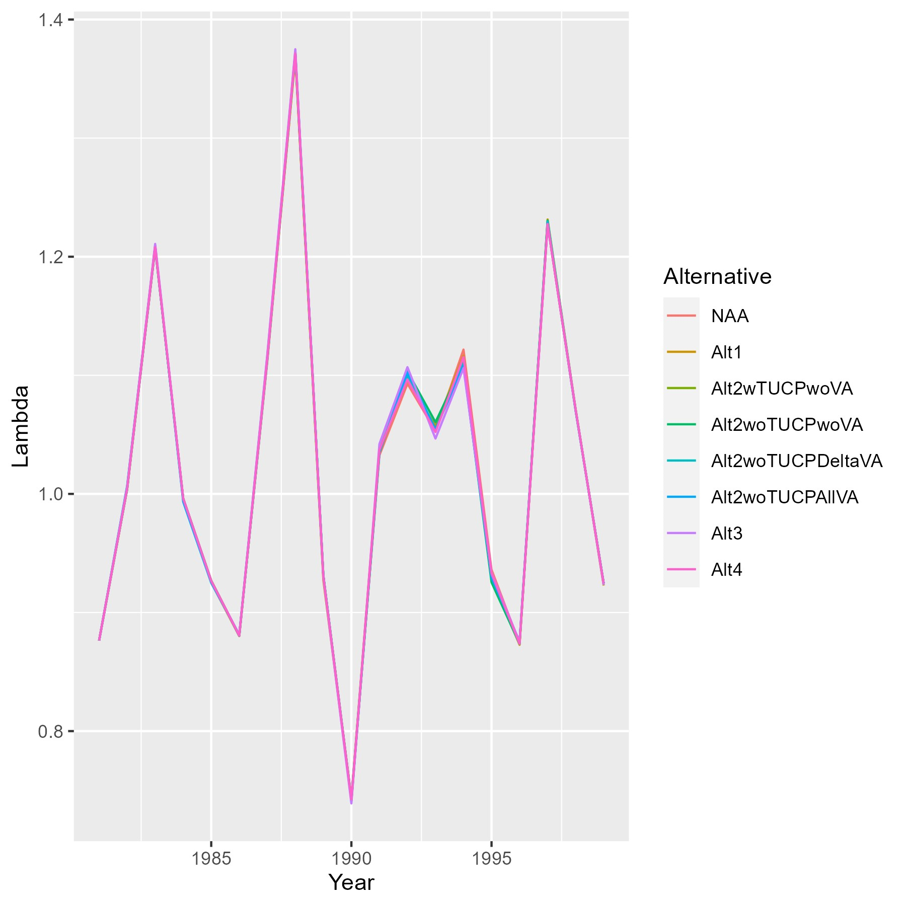

Figure 12. Predicted annual lambda values (Nt/Nt+1) for total spring-run spawner abundance in the Central Valley, including both natural- and hatchery-origin fish, from deterministic model runs.

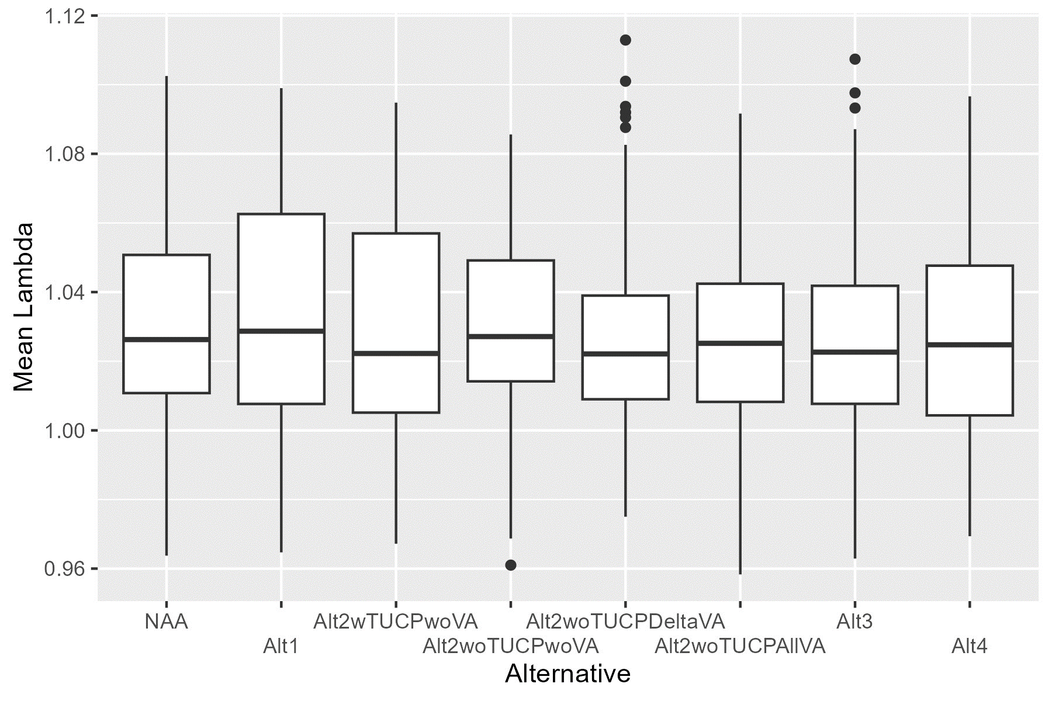

Figure 13. Predicted mean lambda values (Nt/Nt+1) for total spring-run spawner abundance in the Central Valley, including both natural- and hatchery-origin fish, across stochastic model iterations.

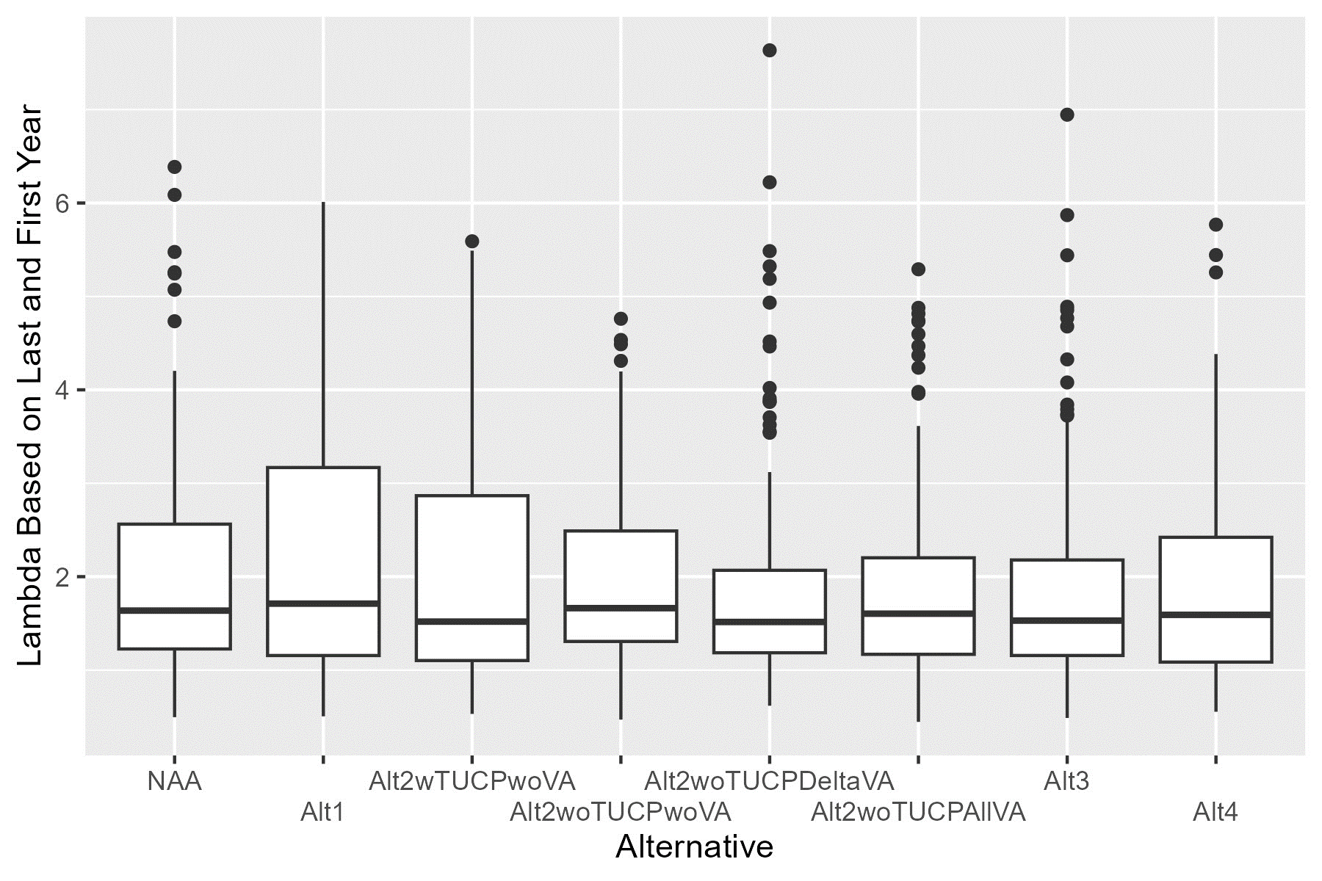

Figure 14. Predicted end lambda values (Nt=19/Nt=1) for total spring-run spawner abundance in the Central Valley, including both natural- and hatchery-origin fish, across stochastic model iterations.

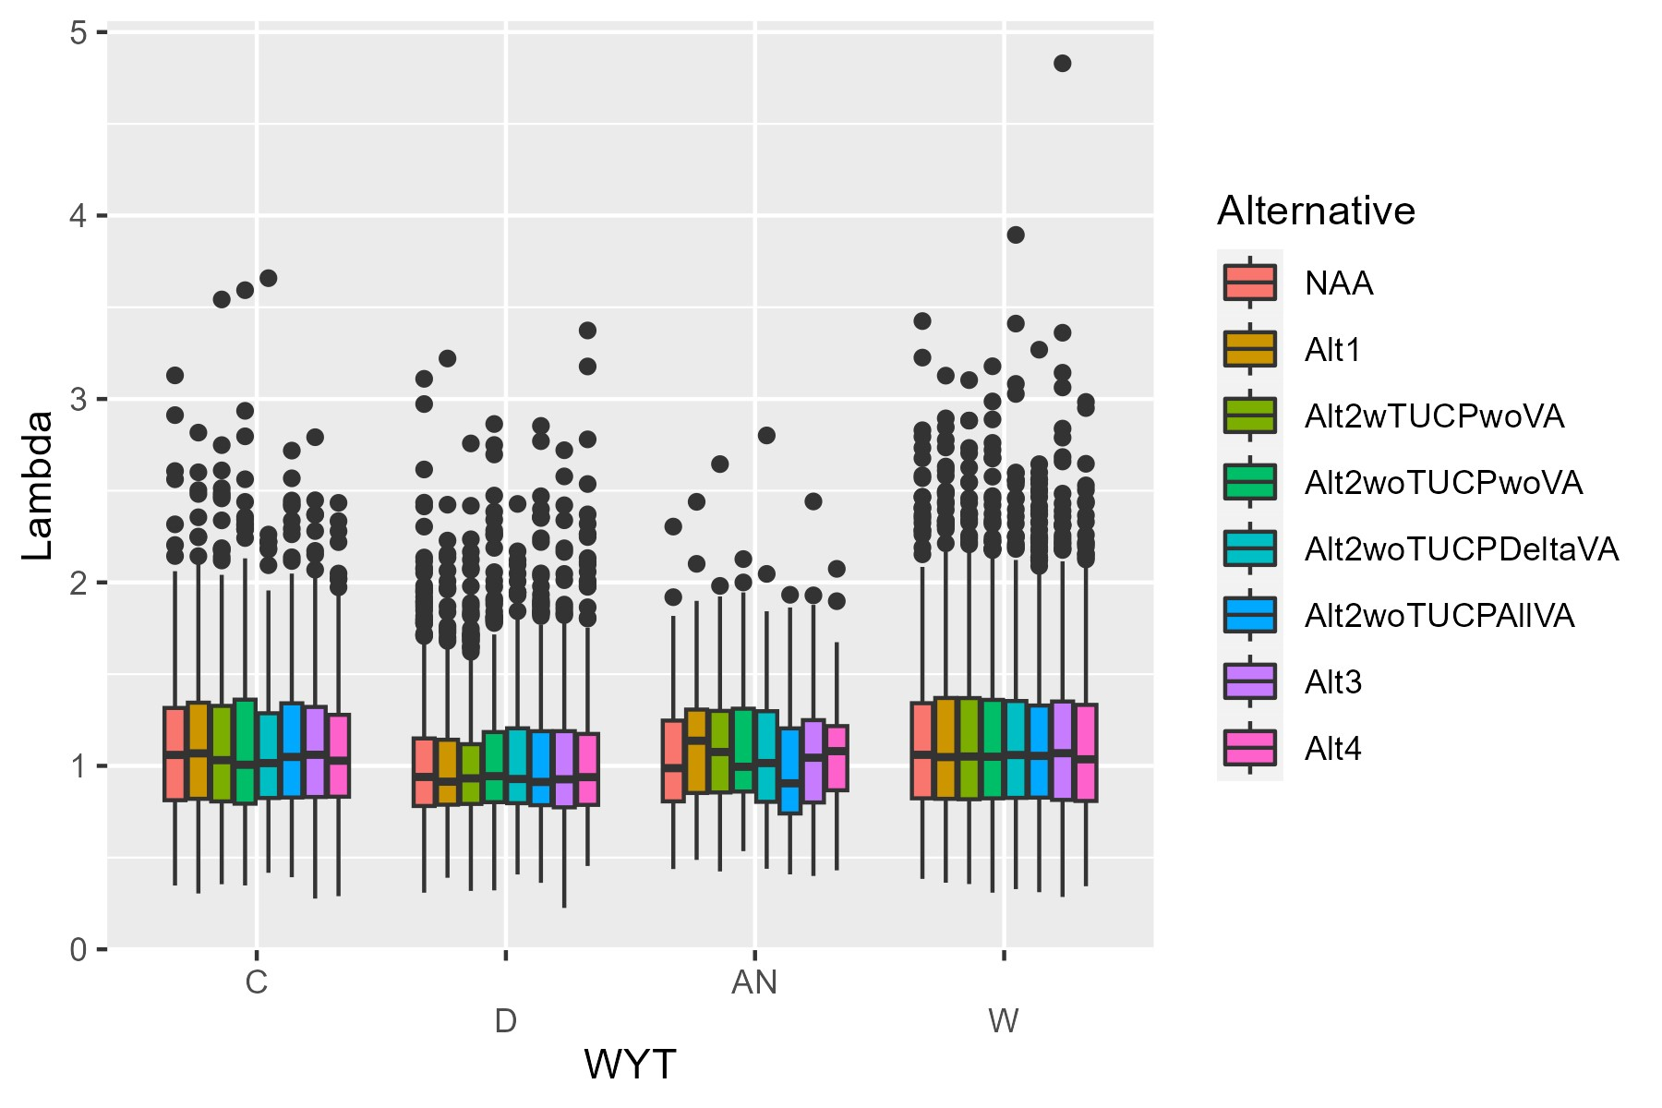

Figure 15. Predicted lambda values across water year types (Nt+1/Nt) for total spring-run spawner abundance in the Central Valley, including both natural- and hatchery-origin fish, across 100 stochastic model iterations.

#### Life stage-specific demographic parameters

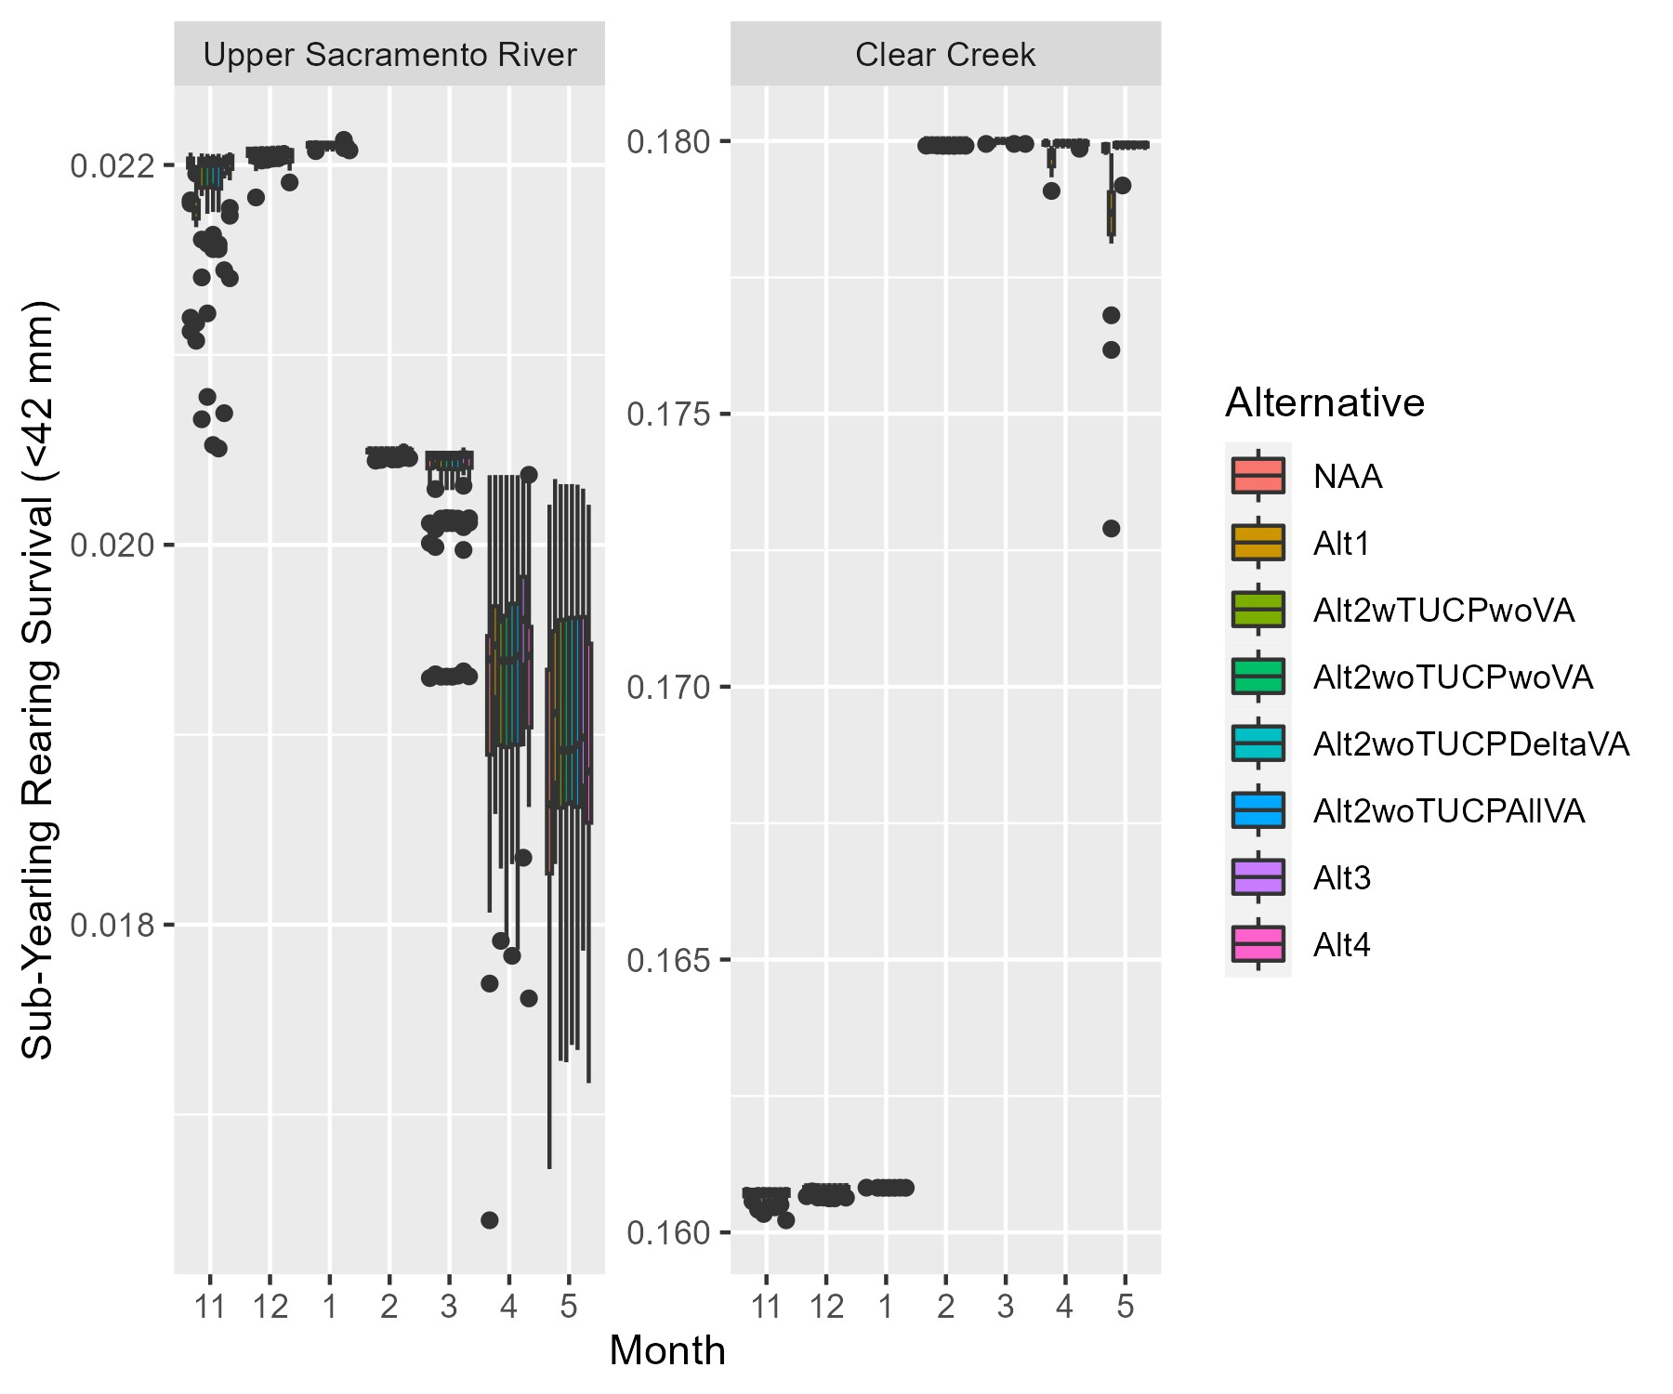

Figure 16. Predicted small, young-of-year, juvenile rearing survival for spring-run Chinook salmon in the Upper Sacramento River and Clear Creek from deterministic model runs.

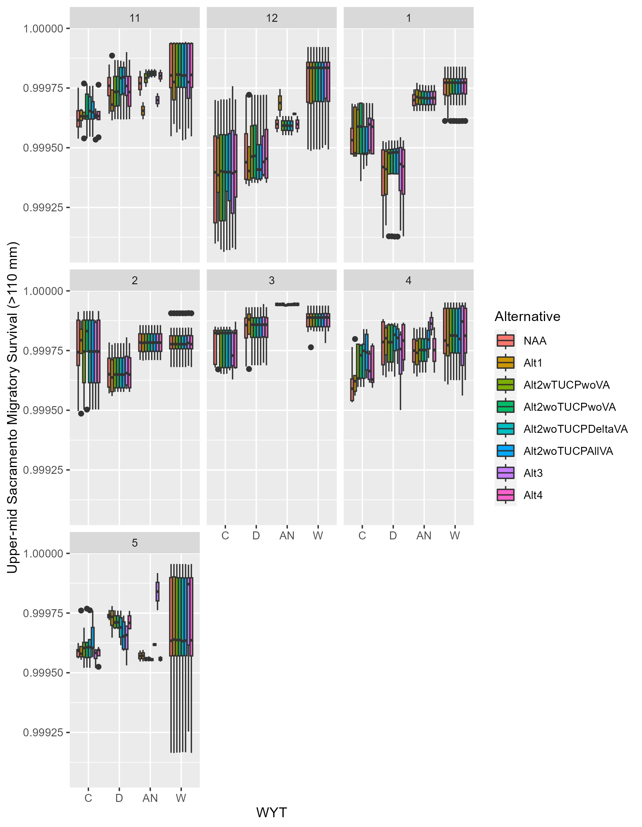

Figure 17. Predicted smolt migratory survival for spring-run Chinook salmon in the Upper-mid Sacramento River from deterministic model runs, faceted by month.



Figure 18. Predicted smolt migratory survival for spring-run Chinook salmon in the Lower-mid Sacramento River from deterministic model runs, faceted by month.

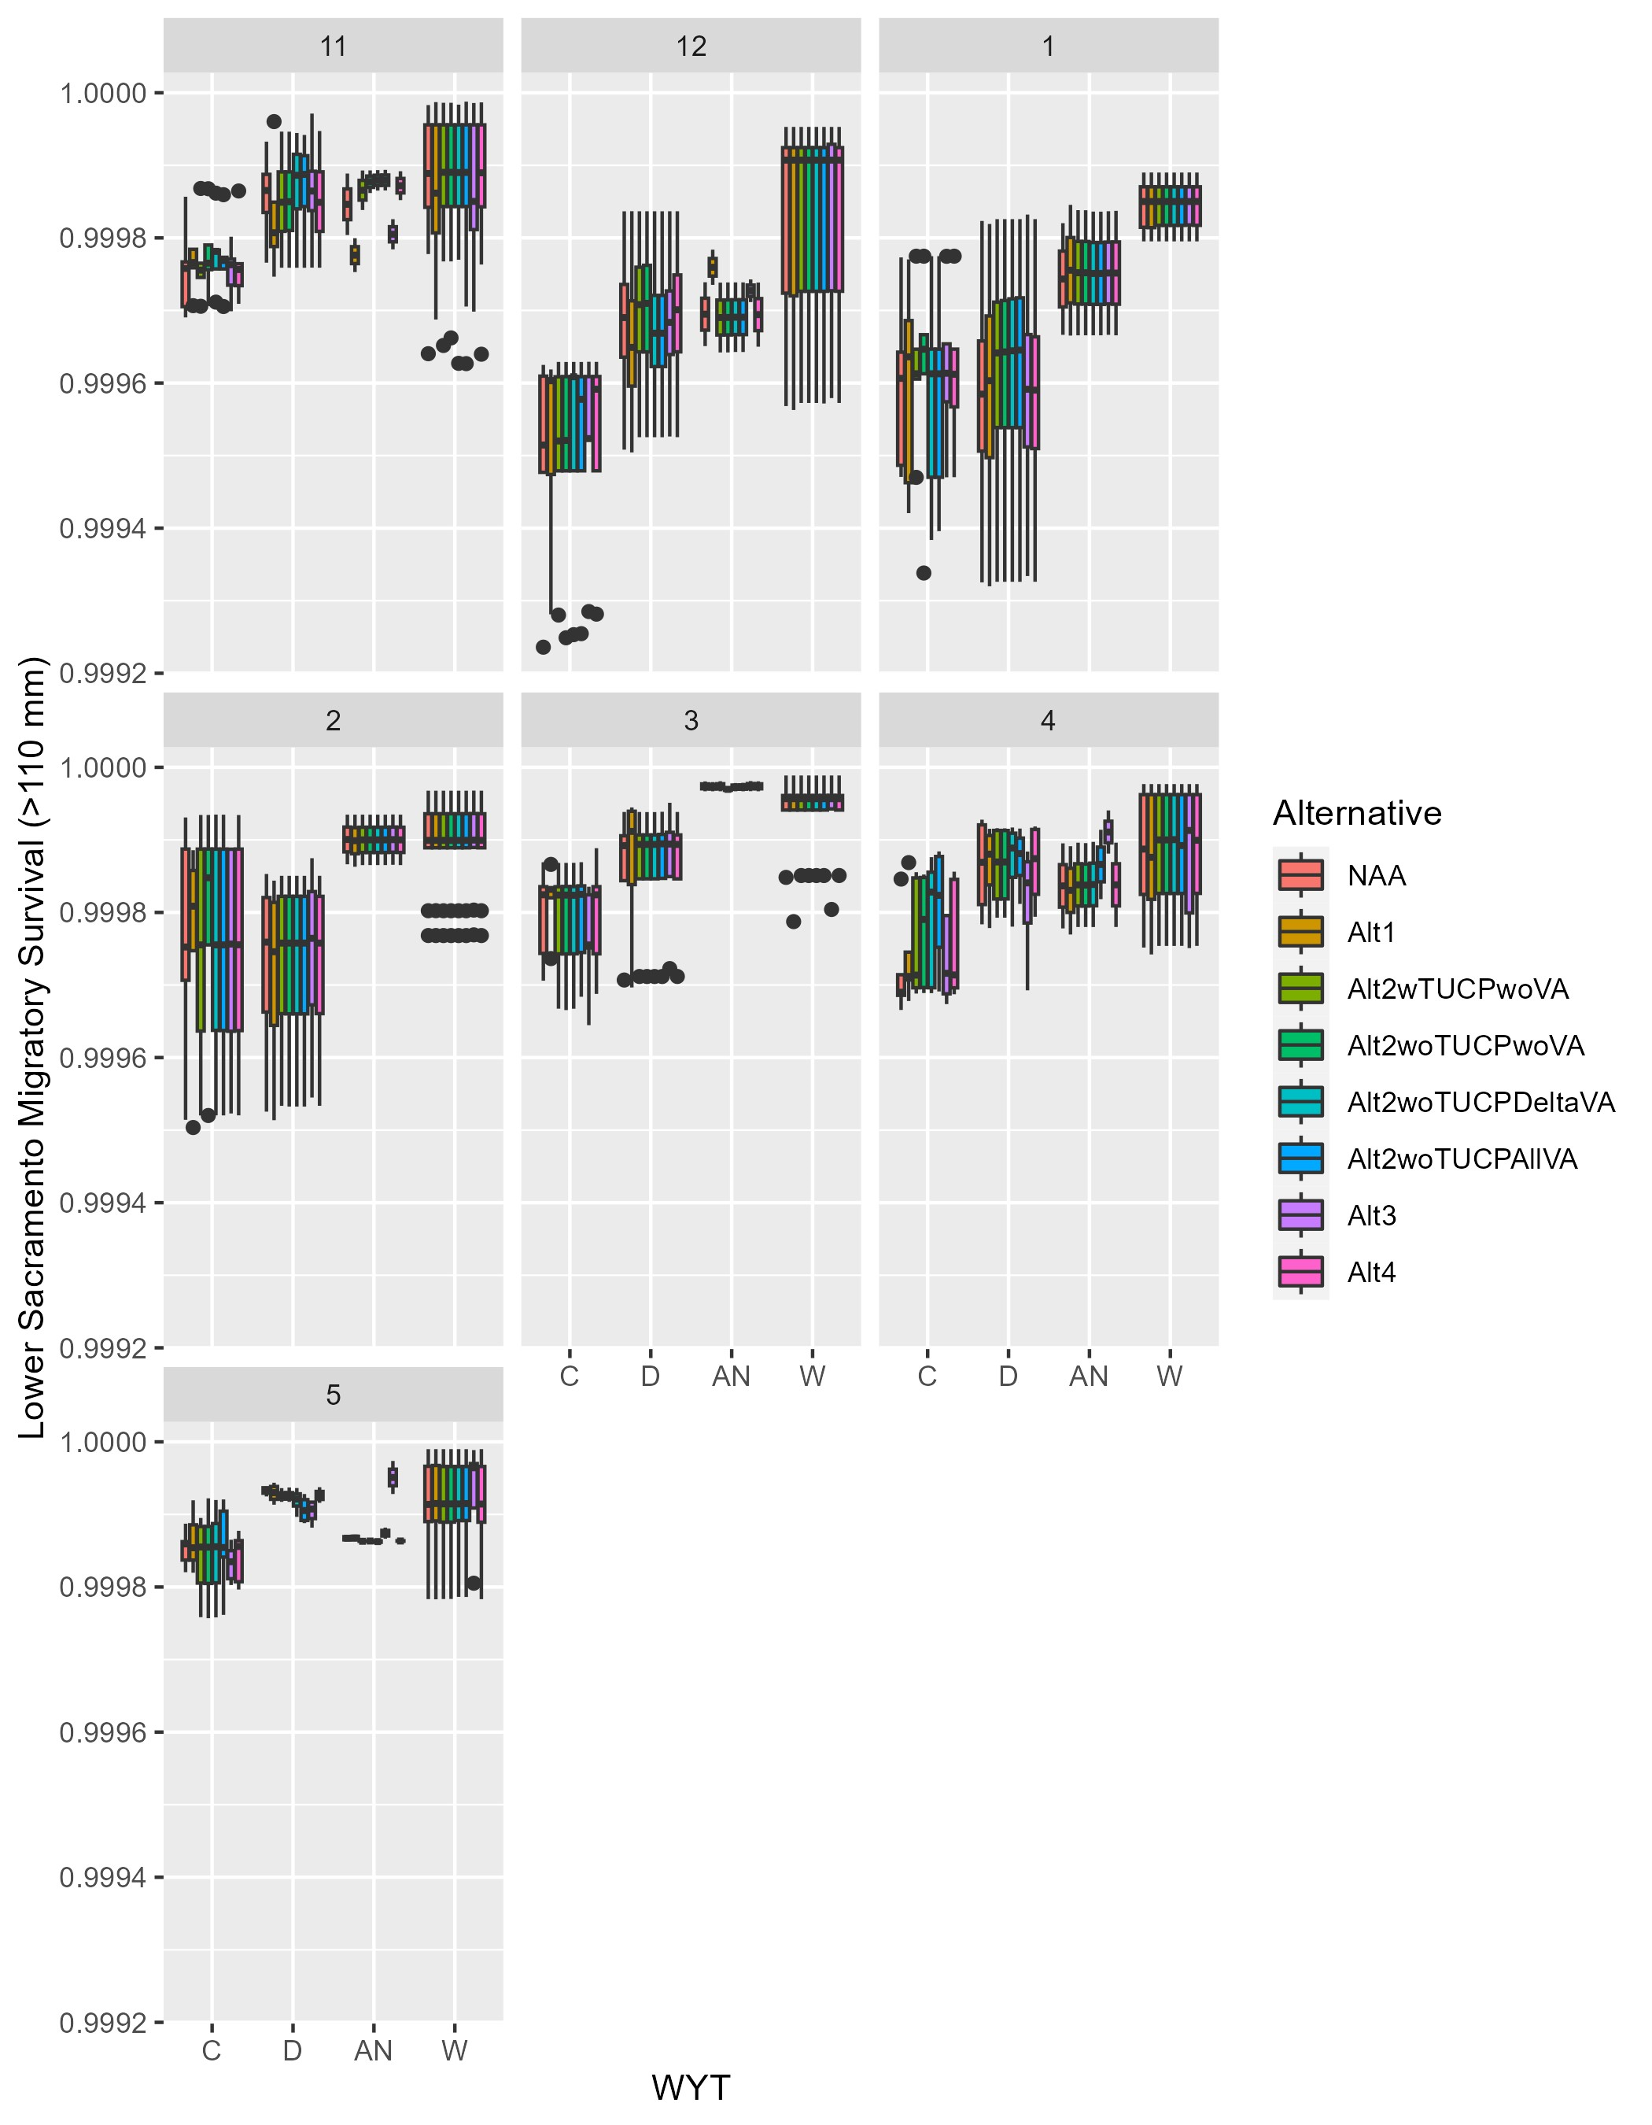

Figure 19. Predicted smolt migratory survival for spring-run Chinook salmon in the Lower Sacramento River from deterministic model runs, faceted by month.

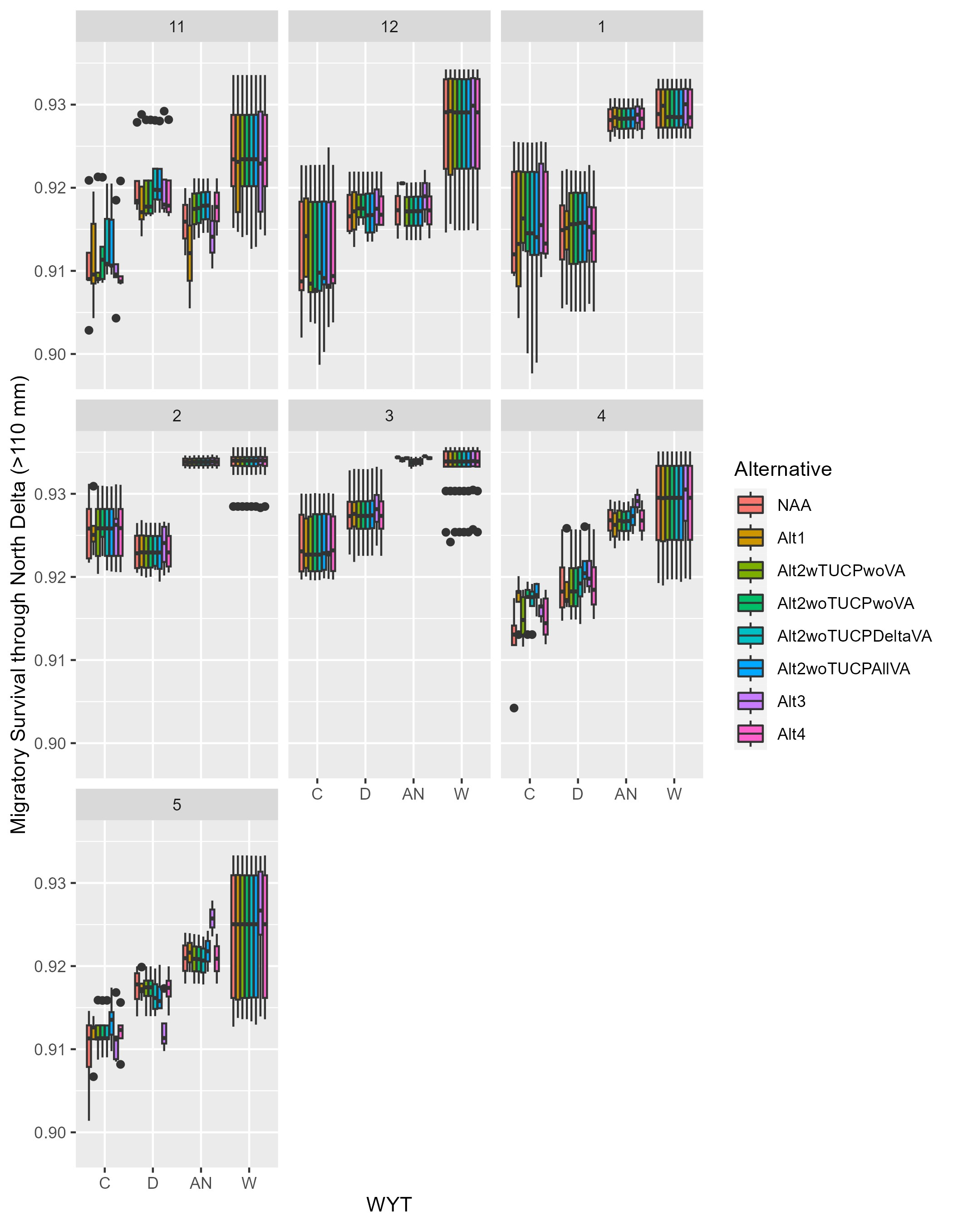

Figure 20. Predicted smolt migratory survival for spring-run Chinook salmon in the North Delta from deterministic model runs, faceted by month.

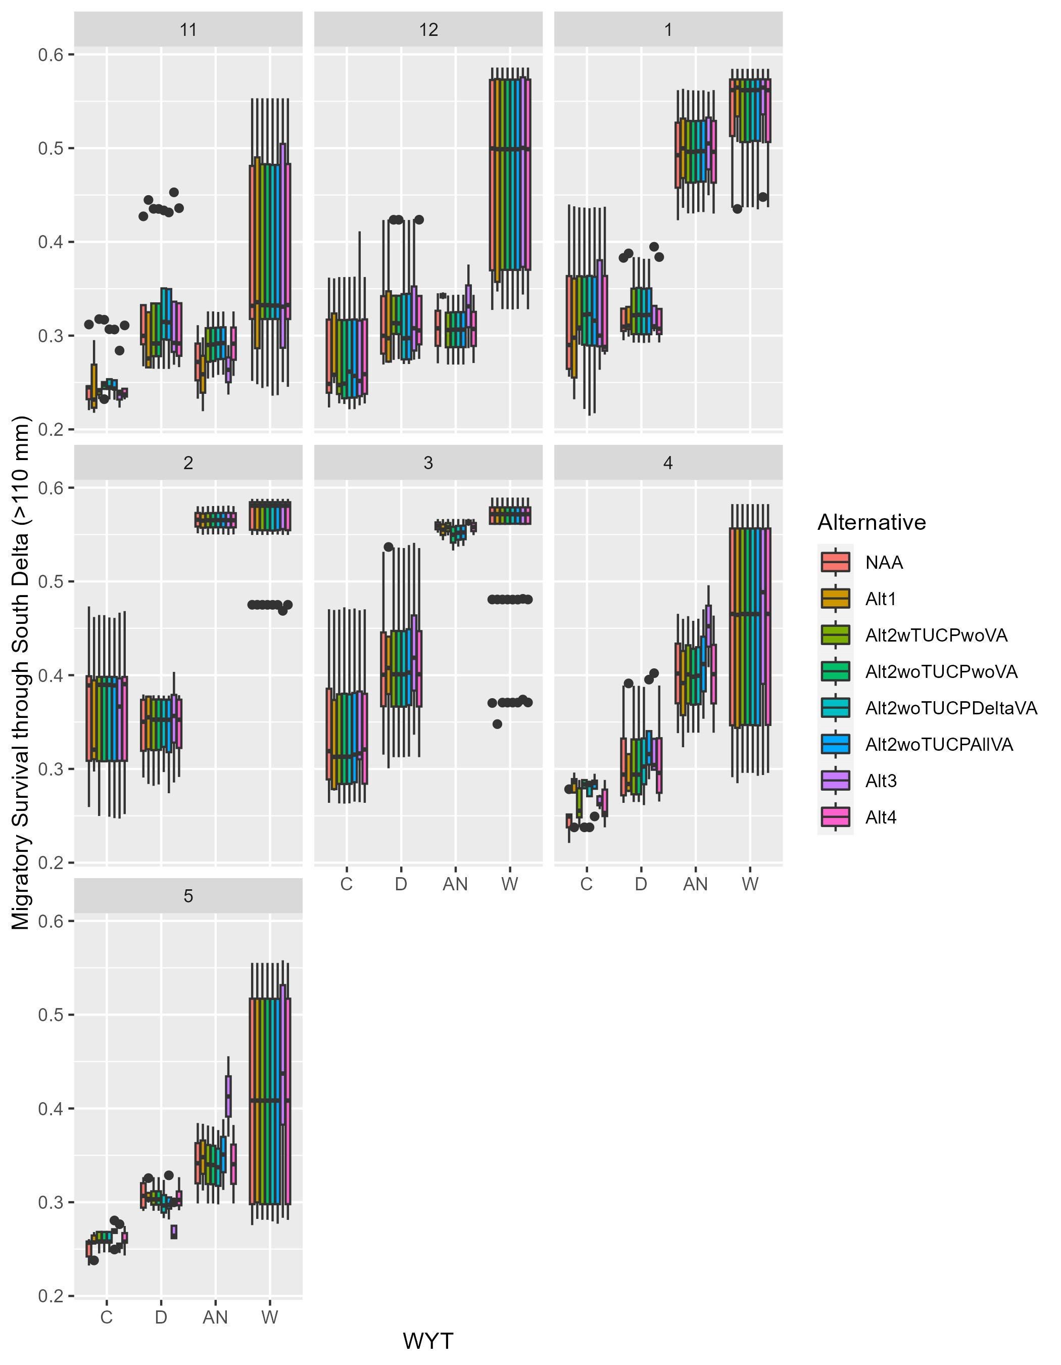

Figure 21. Predicted smolt migratory survival for spring-run Chinook salmon in the South Delta from deterministic model runs, faceted by month.

### BA

Results for the BA are summarized in Tables 7-10 and Figures 22-34.

Predicted total and natural-origin-only spawner abundances in the Central Valley for the deterministic model runs generally fluctuated between 1980 and 1999. The population as a whole and in the Upper Sacramento River reached a low in the early 1980s and peaked in 1988, decreased steadily until 1990 and then generally trended upward (Tables 7, 8; Figs. 22, 23). The Clear Creek natural spawner abundances peaked in 1980 and reached a low in 1990 (Fig. 22). The range of natural-origin-only spawner abundances across alternatives at the end of the time series was narrow, ranging from a low of 12,611 (Alt2wTUCPwoVA) to a high of 12,614 (Alt2woTUCPDeltaVA), excluding baseline alternatives (Table 8); over the entire time series predicted natural-origin-spawner abundances ranged from 7,531 to 14,379 (Table 8). Predicted natural-origin-only spawner abundances in the Central Valley varied more widely across stochastic model runs, from a low of approximately 0 to a high of approximately 100,000 spawners (Fig. 24).

For deterministic model runs, population change over time, defined by mean (i.e., geometric) lambda values (Nt/Nt+1), over the entire 1980-1999 time series was consistently at 1.01 across all alternatives (Table 9), and terminal lambda values (Nt=19/Nt=1) were consistently 1.205 (Table 10). These values indicated that predicted spawner abundances increased over the course of the time series (Tables 9, 10). Annual lambda values from deterministic model runs ranged from approximately 0.75 to 1.37 (Fig. 25). Mean lambda values across stochastic model iterations ranged from approximately 0.96 to 1.11 (Fig. 26). Terminal lambda values from stochastic models ranged from approximately 0.5 to 7.5 (Fig. 27), suggesting some model runs resulted in expected population growth over the time series. Under deterministic models, Critical water years had the highest mean annual lambdas (>1.07) and Above Normal and Wet water years also had a mean annual lambda greater than 1, indicating that the population grew in both wetter and drier conditions, just not under Dry water year types (Table 9). Mean lambdas were less than 1 in Dry water years, indicating that populations declined. Likewise, across stochastic model runs, Dry water years had a lower mean lambda value than other water year types (Fig. 28). Reclamation staff note that spawner abundances in any given year (or water year type) reflect a multitude of influences over time (e.g., previous spawner abundances and rearing conditions), and not just flow and temperature conditions during the spawning year.

Population trends may be explained by differences in life stage-specific demographic parameters. It is worth emphasizing again that the egg-to-fry survival life stage transition in the DSM is not sensitive to alternative-dependent flow or temperature values, and thus will be constant across alternatives. Across deterministic runs, monthly rearing survival for small juveniles (i.e., <42 mm) in the Upper Sacramento River varied from a low of approximately 0.016 to a high of approximately 0.024, excluding baseline alternatives (Fig. 29); rearing survival in the Upper Sacramento River also varied across months, peaking in December and January, and showing greater variation across water years in April and May. In Clear Creek, monthly rearing survival for small juveniles (i.e., <42 mm) and varied across deterministic runs from approximately 0.12 to 0.18; rearing survival in Clear Creek also varied across months, with greater survival in February-May and lower survival in November-January.

Model-estimated migratory survival for very large fish (i.e., smolt size, >110 mm) in the Upper-mid, Lower-mid, and Lower Sacramento River was very close to 1, with slight variations across months and water year types (WYTs) (Figs. 30-32). In the Upper-mid and Lower-mid, and Lower Sacramento River, expected survival was consistently highest in Wet years. Migratory survival for very large fish also varied across months and WYT in the North and South Delta (Figs. 33-34). Migratory survival often increased moving from a Critical to Dry to Above Normal to Wet WYT. In the North Delta, migratory survival was relatively high, ranging from 0.894 – 0.935, and lower in the South Delta, ranging from 0.205 – 0.576. In the South Delta, expected migratory survival was greatest in February and March (0.467-0.505 across all water year types) and lowest in November (0.301 – 0.333 across all water year types). With migratory survival in the mainstem Sacramento River and North Delta high across the alternatives, rearing survival and migratory survival in the South Delta likely act as drivers of lambda.

#### Population abundance, trends

Table 7. Predicted annual total spring-run spawner abundance in the Central Valley, including both natural- and hatchery-origin fish, from deterministic model runs.

| Year | EXP1 | EXP3 | NAA | Alt2wTUCPwoVA | Alt2woTUCPwoVA | Alt2woTUCPDeltaVA | Alt2woTUCPAllVA |
| --- | --- | --- | --- | --- | --- | --- | --- |
| 1980 | 14889 | 14887 | 14886 | 14886 | 14886 | 14886 | 14886 |
| 1981 | 13041 | 13045 | 13045 | 13045 | 13045 | 13045 | 13045 |
| 1982 | 13242 | 13139 | 13094 | 13098 | 13098 | 13109 | 13134 |
| 1983 | 16213 | 15968 | 15808 | 15819 | 15819 | 15837 | 15881 |
| 1984 | 16135 | 15952 | 15749 | 15759 | 15759 | 15764 | 15777 |
| 1985 | 14933 | 14816 | 14600 | 14604 | 14604 | 14601 | 14595 |
| 1986 | 13255 | 13111 | 12862 | 12858 | 12859 | 12854 | 12863 |
| 1987 | 14743 | 14676 | 14297 | 14320 | 14320 | 14314 | 14356 |
| 1988 | 20008 | 19998 | 19576 | 19637 | 19637 | 19640 | 19713 |
| 1989 | 18408 | 18325 | 18234 | 18277 | 18277 | 18283 | 18354 |
| 1990 | 13716 | 13517 | 13536 | 13552 | 13553 | 13575 | 13602 |
| 1991 | 14492 | 14127 | 13976 | 14025 | 14027 | 14068 | 14081 |
| 1992 | 15958 | 15444 | 15275 | 15425 | 15476 | 15465 | 15528 |
| 1993 | 16758 | 16202 | 16086 | 16275 | 16412 | 16299 | 16374 |
| 1994 | 18607 | 18142 | 18044 | 18126 | 18218 | 18099 | 18143 |
| 1995 | 17255 | 16976 | 16891 | 16890 | 16860 | 16828 | 16862 |
| 1996 | 15057 | 14826 | 14757 | 14762 | 14728 | 14731 | 14760 |
| 1997 | 18618 | 18270 | 18116 | 18121 | 18122 | 18116 | 18128 |
| 1998 | 19919 | 19592 | 19404 | 19400 | 19401 | 19399 | 19397 |
| 1999 | 18239 | 18032 | 17936 | 17936 | 17938 | 17938 | 17937 |

Table 8. Predicted annual natural-origin spring-run spawner abundance in the Central Valley from deterministic model runs.

| Year | EXP1 | EXP3 | NAA | Alt2wTUCPwoVA | Alt2woTUCPwoVA | Alt2woTUCPDeltaVA | Alt2woTUCPAllVA |
| --- | --- | --- | --- | --- | --- | --- | --- |
| 1980 | 9565 | 9563 | 9561 | 9562 | 9562 | 9562 | 9562 |
| 1981 | 7709 | 7711 | 7712 | 7712 | 7712 | 7712 | 7712 |
| 1982 | 7919 | 7816 | 7771 | 7775 | 7775 | 7786 | 7811 |
| 1983 | 10890 | 10645 | 10485 | 10496 | 10496 | 10514 | 10558 |
| 1984 | 10811 | 10628 | 10424 | 10434 | 10434 | 10439 | 10452 |
| 1985 | 9600 | 9483 | 9267 | 9270 | 9270 | 9268 | 9261 |
| 1986 | 7932 | 7788 | 7539 | 7535 | 7536 | 7531 | 7540 |
| 1987 | 9411 | 9342 | 8964 | 8987 | 8987 | 8981 | 9023 |
| 1988 | 14674 | 14664 | 14243 | 14303 | 14303 | 14306 | 14379 |
| 1989 | 13075 | 12991 | 12901 | 12944 | 12944 | 12950 | 13020 |
| 1990 | 8387 | 8187 | 8206 | 8222 | 8223 | 8245 | 8272 |
| 1991 | 9159 | 8794 | 8643 | 8692 | 8694 | 8735 | 8748 |
| 1992 | 10625 | 10111 | 9942 | 10092 | 10143 | 10131 | 10195 |
| 1993 | 11433 | 10878 | 10762 | 10950 | 11088 | 10975 | 11049 |
| 1994 | 13274 | 12807 | 12710 | 12792 | 12885 | 12766 | 12810 |
| 1995 | 11932 | 11653 | 11568 | 11567 | 11537 | 11505 | 11539 |
| 1996 | 9734 | 9501 | 9434 | 9439 | 9405 | 9408 | 9437 |
| 1997 | 13289 | 12945 | 12791 | 12796 | 12797 | 12792 | 12804 |
| 1998 | 14596 | 14269 | 14081 | 14077 | 14078 | 14076 | 14074 |
| 1999 | 12915 | 12707 | 12611 | 12611 | 12613 | 12614 | 12613 |

Table 9. Predicted mean lambda (Nt/Nt+1) for total spring-run spawner abundance in the Central Valley, including both natural- and hatchery-origin fish, from deterministic model runs.

| WYT | EXP1 | EXP3 | NAA | Alt2wTUCPwoVA | Alt2woTUCPwoVA | Alt2woTUCPDeltaVA | Alt2woTUCPAllVA |
| --- | --- | --- | --- | --- | --- | --- | --- |
| C | 1.074 | 1.072 | 1.072 | 1.072 | 1.072 | 1.072 | 1.072 |
| D | 0.958 | 0.960 | 0.962 | 0.962 | 0.962 | 0.962 | 0.962 |
| AN | 1.050 | 1.049 | 1.053 | 1.055 | 1.060 | 1.054 | 1.054 |
| W | 1.016 | 1.016 | 1.013 | 1.013 | 1.013 | 1.013 | 1.013 |
| All | 1.011 | 1.010 | 1.010 | 1.010 | 1.010 | 1.010 | 1.010 |

Table 10. Predicted terminal lambda (Nt=19/Nt=1) for total spring-run spawner abundance in the Central Valley, including both natural- and hatchery-origin fish, from deterministic model runs.

| EXP1 | EXP3 | NAA | Alt2wTUCPwoVA | Alt2woTUCPwoVA | Alt2woTUCPDeltaVA | Alt2woTUCPAllVA |
| --- | --- | --- | --- | --- | --- | --- |
| 1.225 | 1.211 | 1.205 | 1.205 | 1.205 | 1.205 | 1.205 |

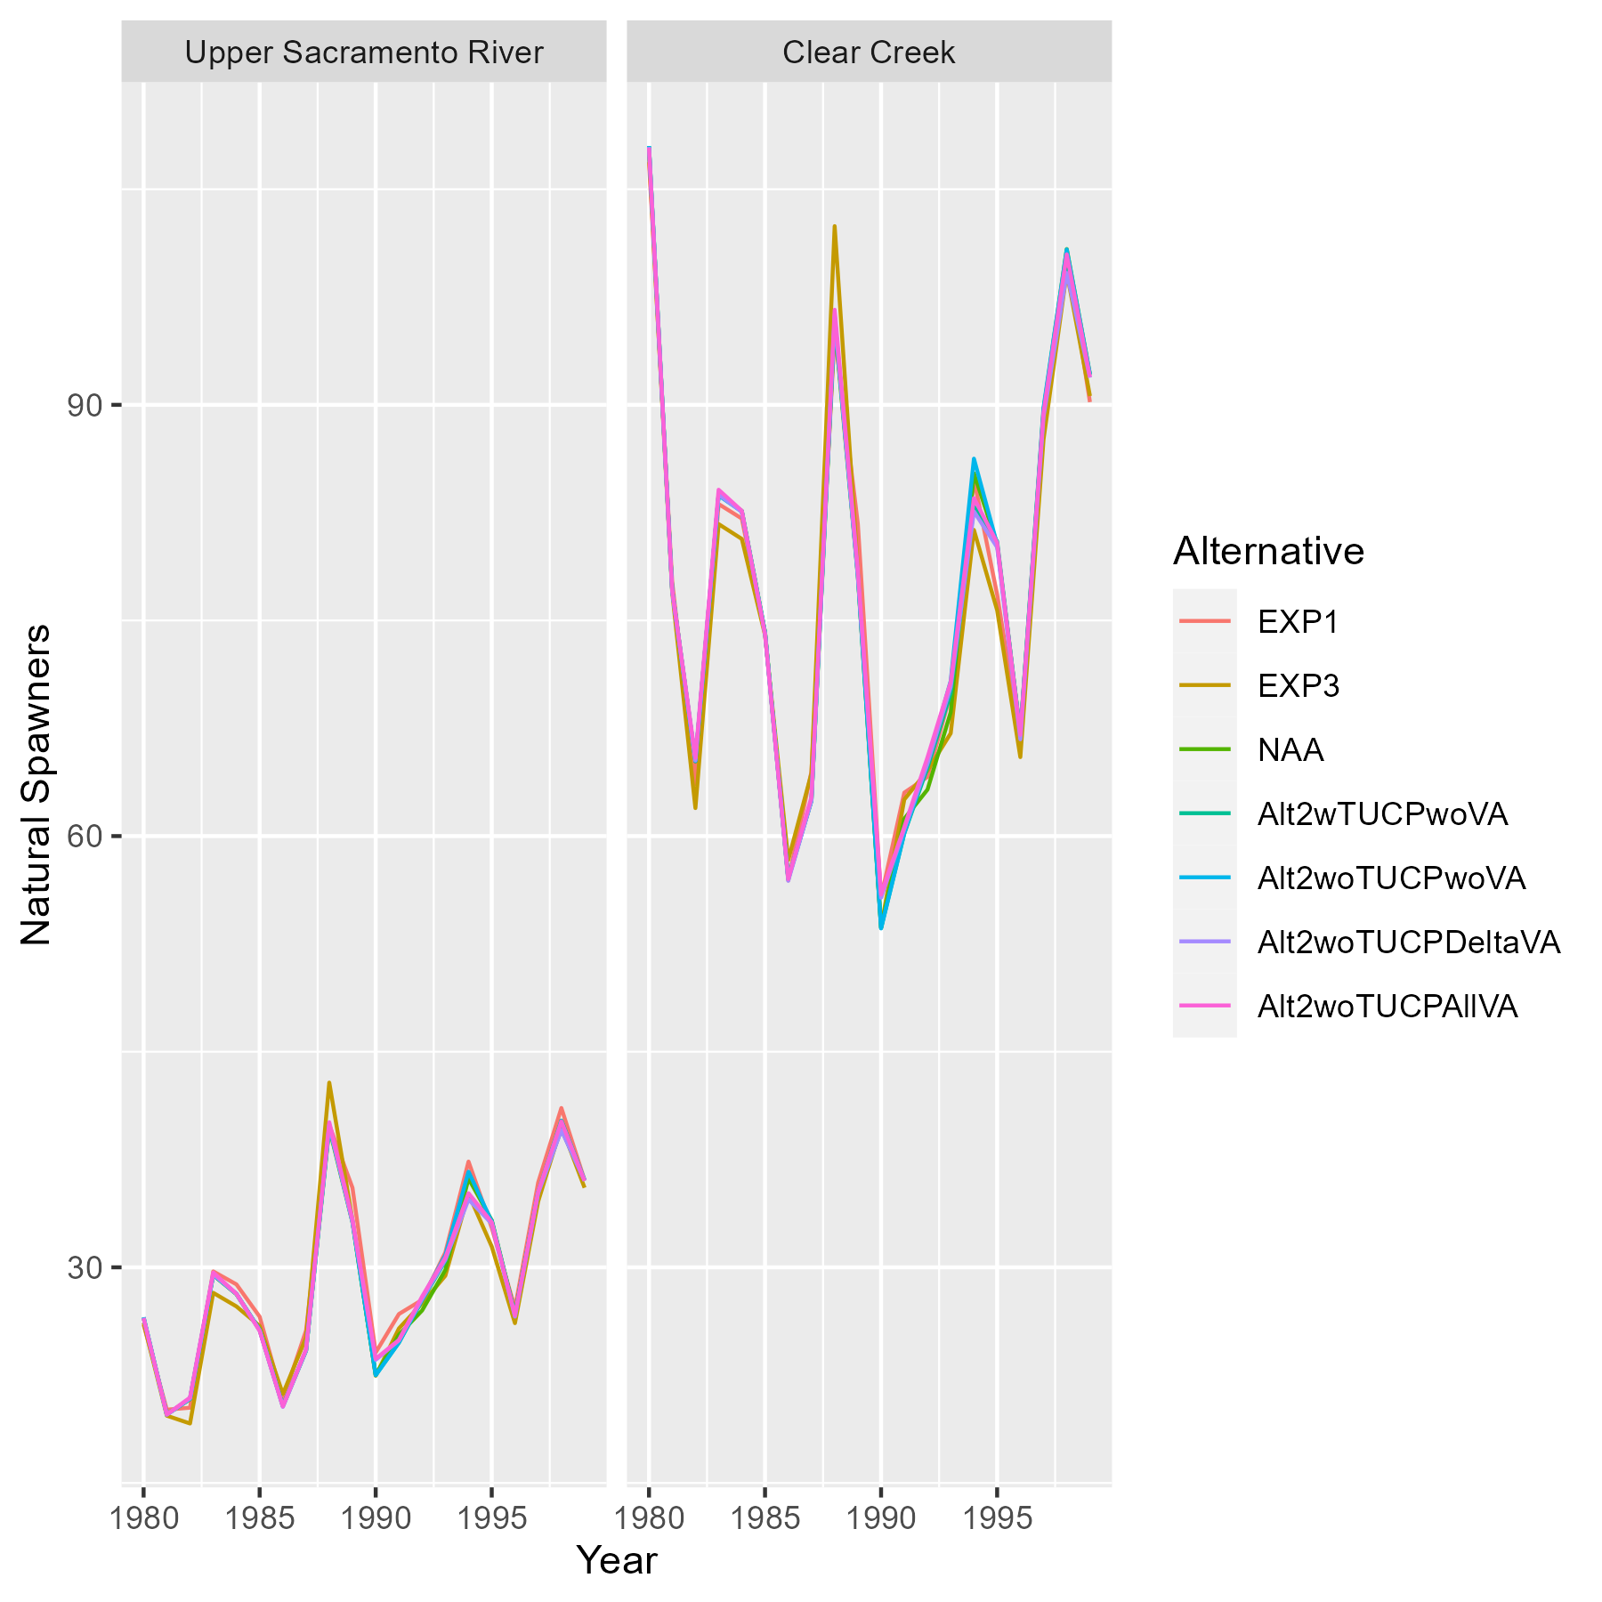

Figure 22. Expected annual abundances of natural-origin spring-run Chinook salmon spawners in the Upper Sacramento River and Clear Creek from deterministic model runs.

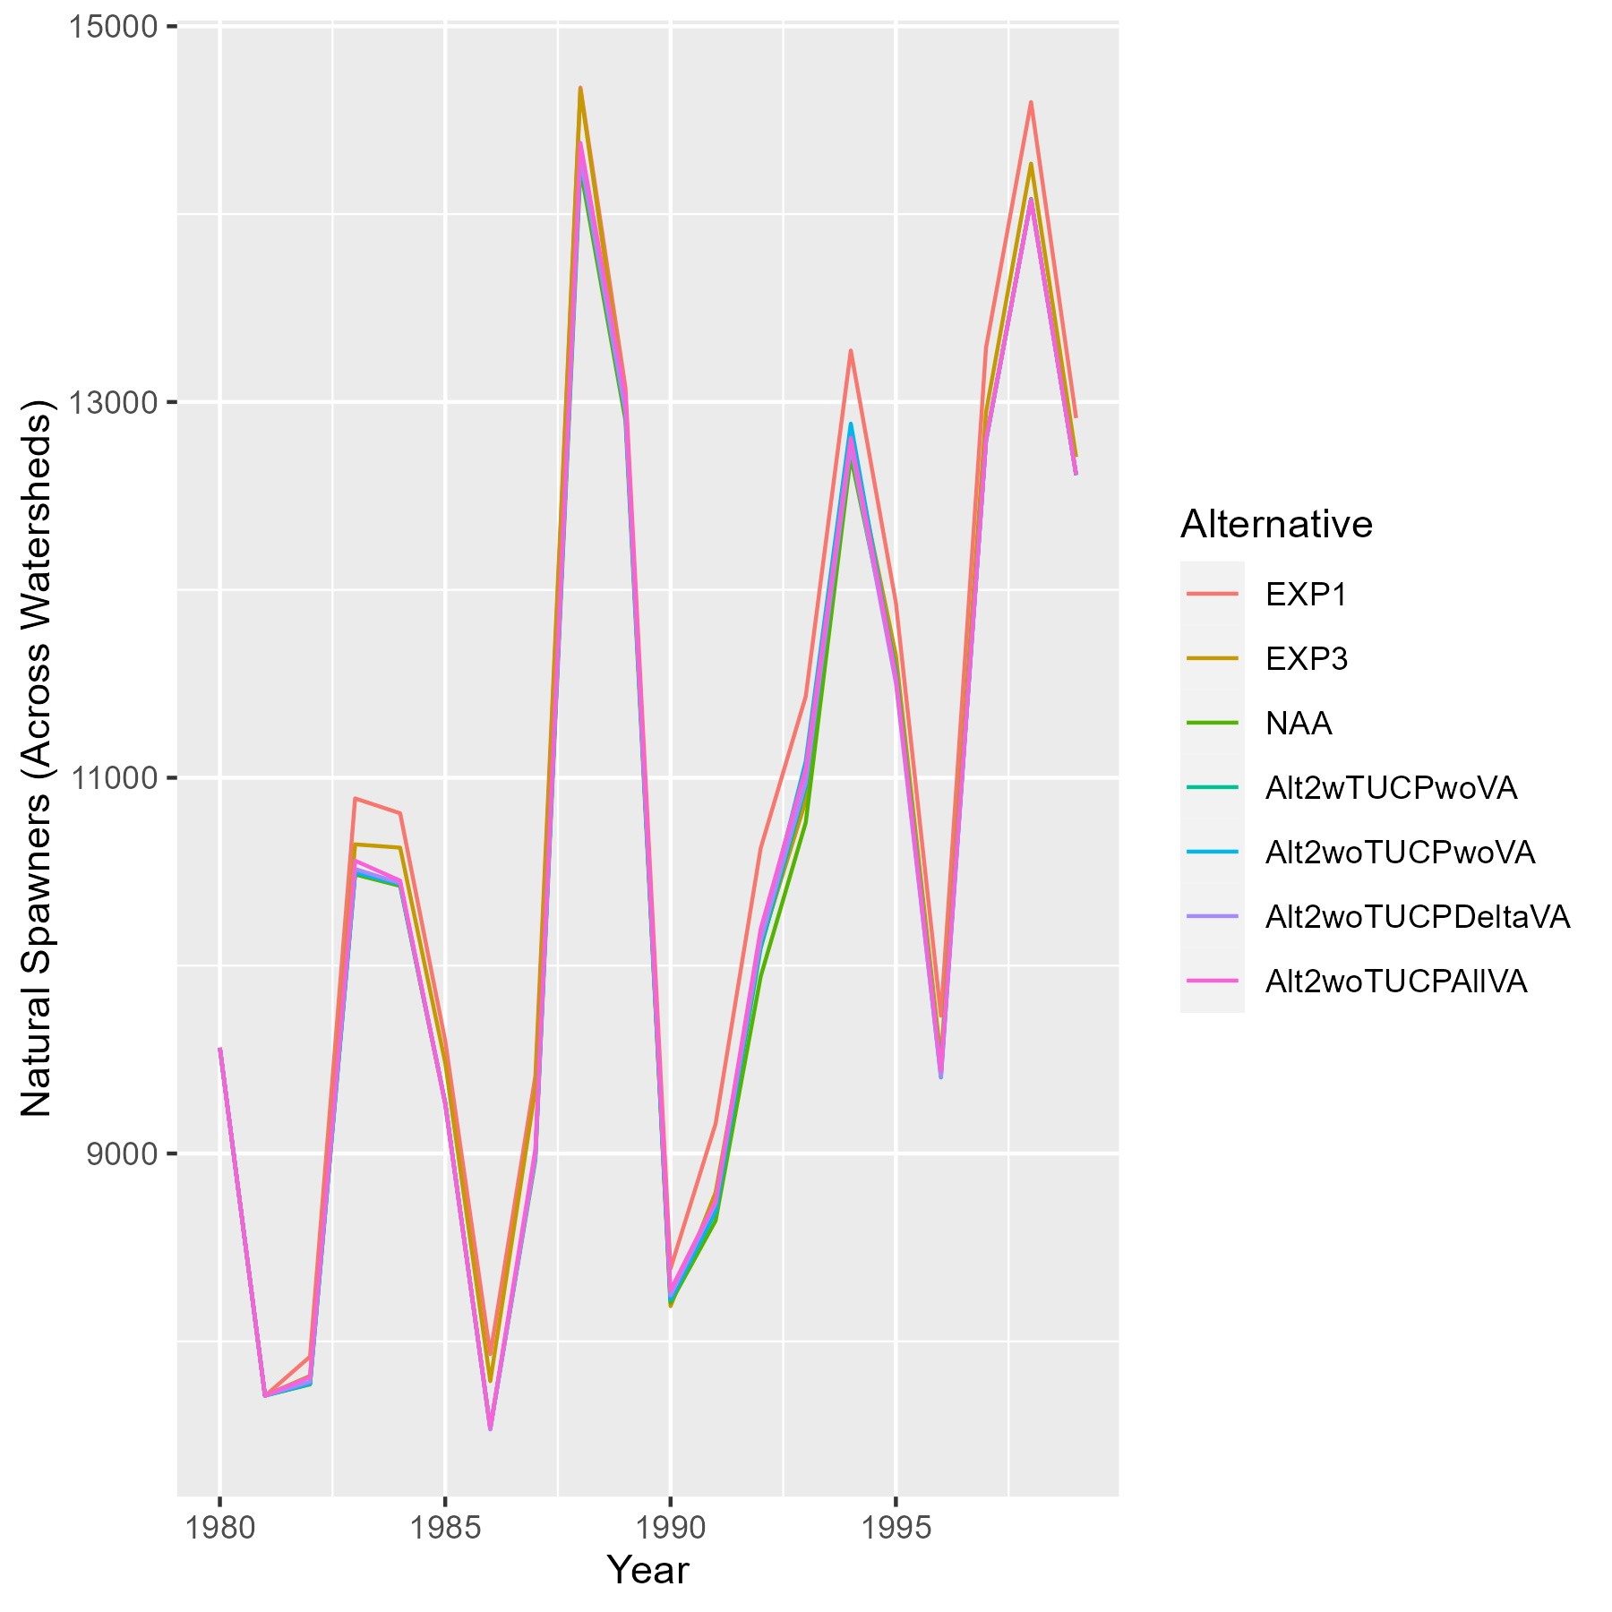

Figure 23. Expected annual abundances of natural-origin spring-run Chinook salmon spawners in the Central Valley from deterministic model runs.

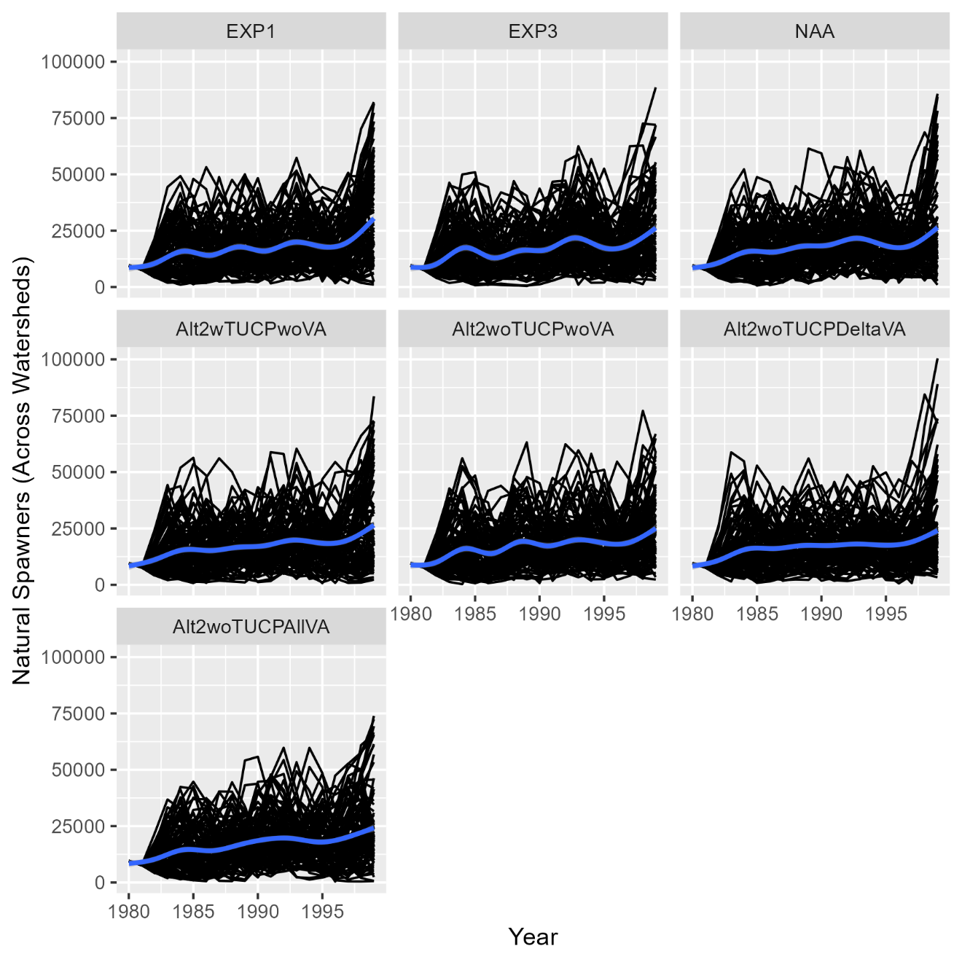

Figure 24. Expected annual abundances of natural-origin spring-run Chinook salmon spawners in the Central Valley from stochastic model runs. Black lines represent iteration-specific abundances over time and the blue line represents an expected trend obtained by ‘gam’ smoothing in ggplot2.

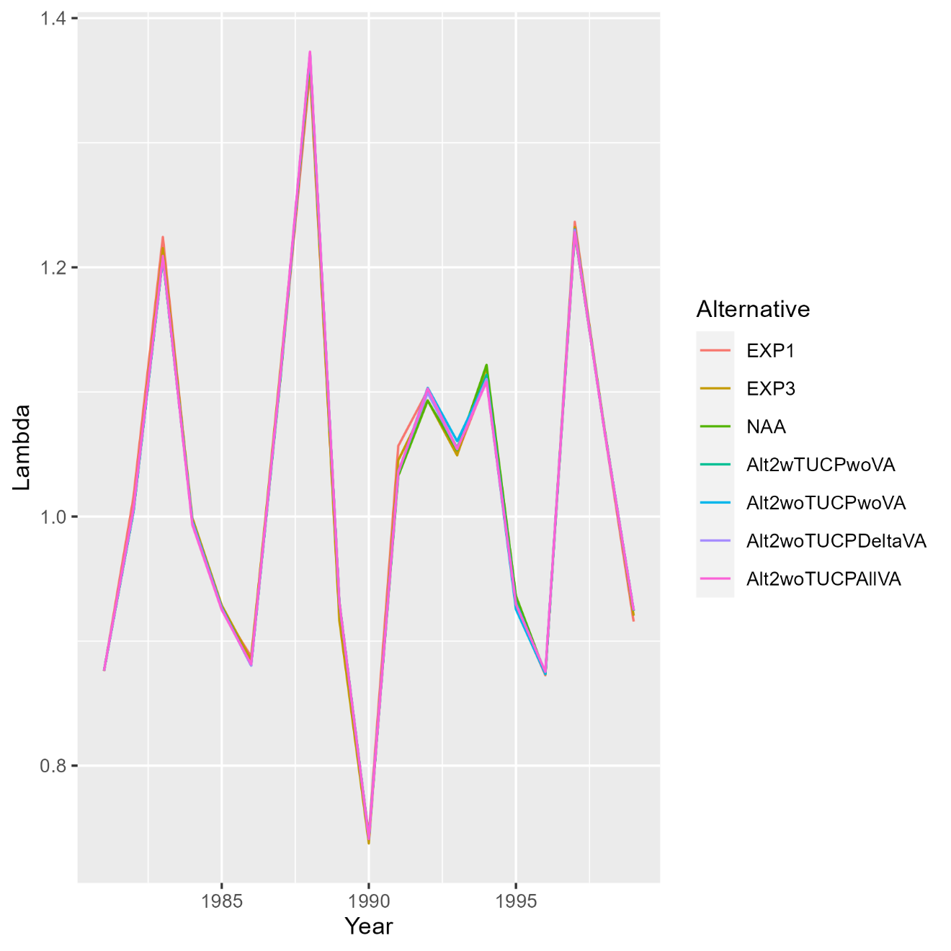

Figure 25. Predicted annual lambda values (Nt/Nt+1) for total spring-run spawner abundance in the Central Valley, including both natural- and hatchery-origin fish, from deterministic model runs.

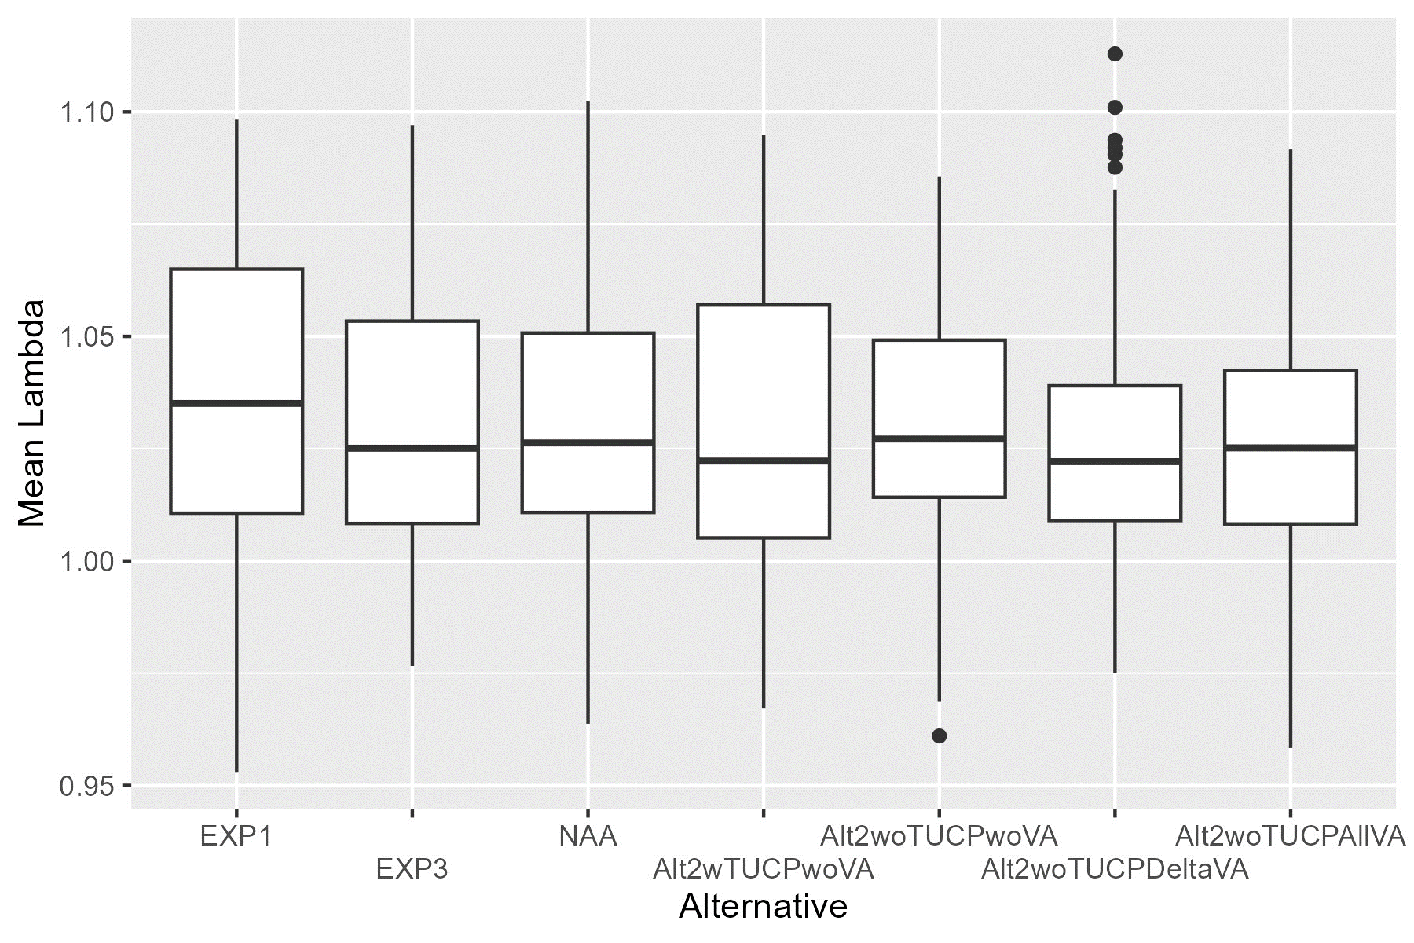

Figure 26. Predicted mean lambda values (Nt/Nt+1) for total spring-run spawner abundance in the Central Valley, including both natural- and hatchery-origin fish, across stochastic model iterations.

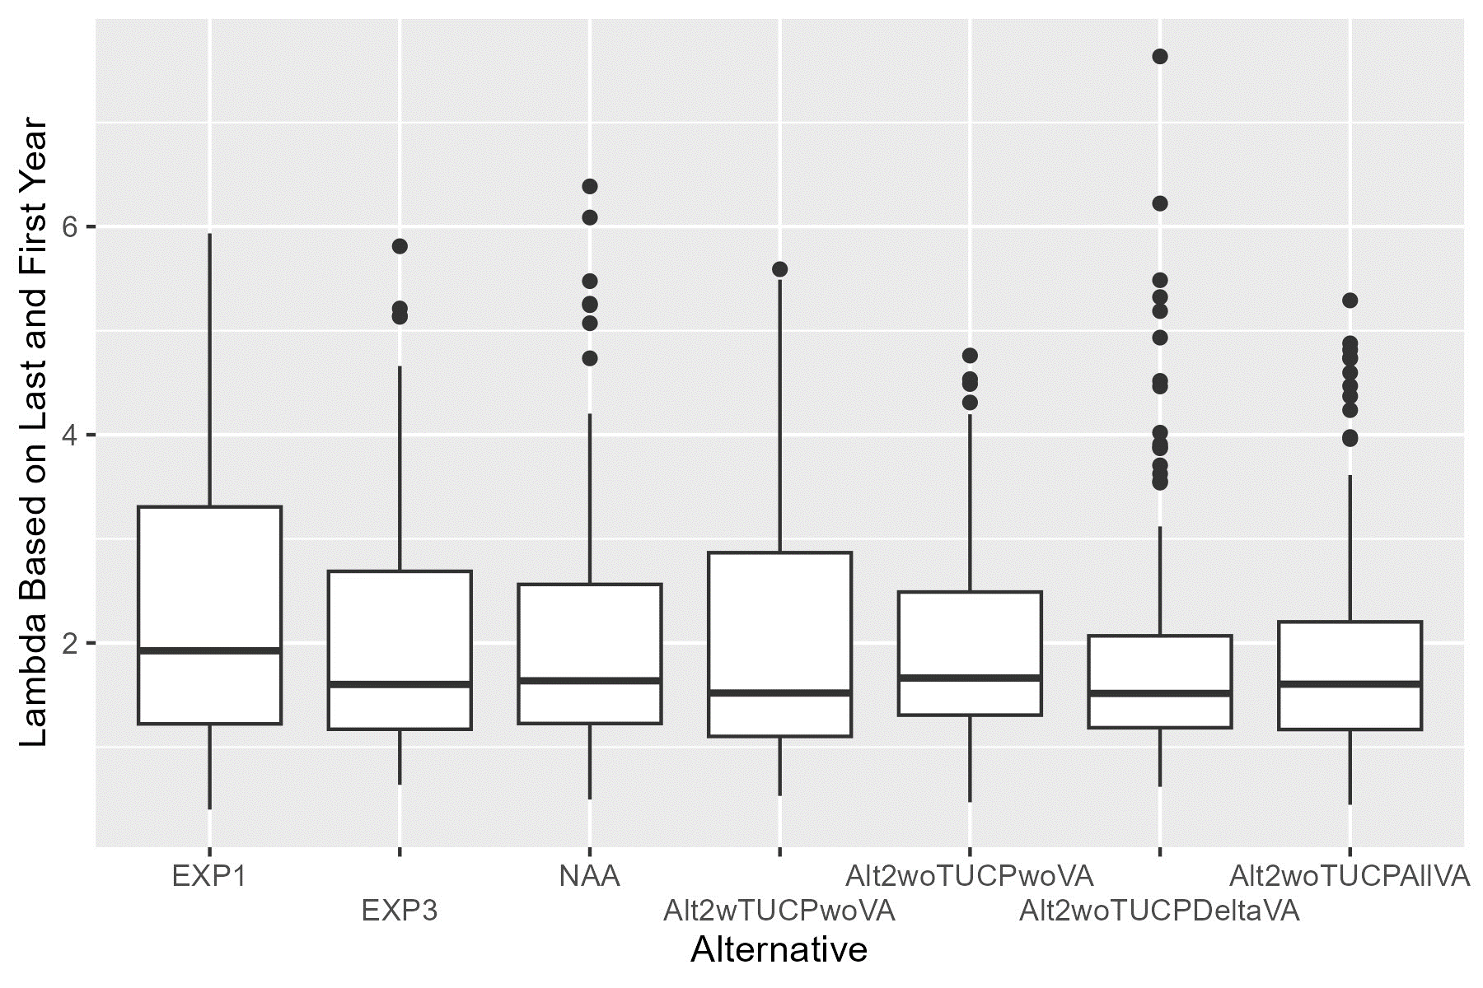

Figure 27. Predicted end lambda values (Nt=19/Nt=1) for total spring-run spawner abundance in the Central Valley, including both natural- and hatchery-origin fish, across stochastic model iterations.

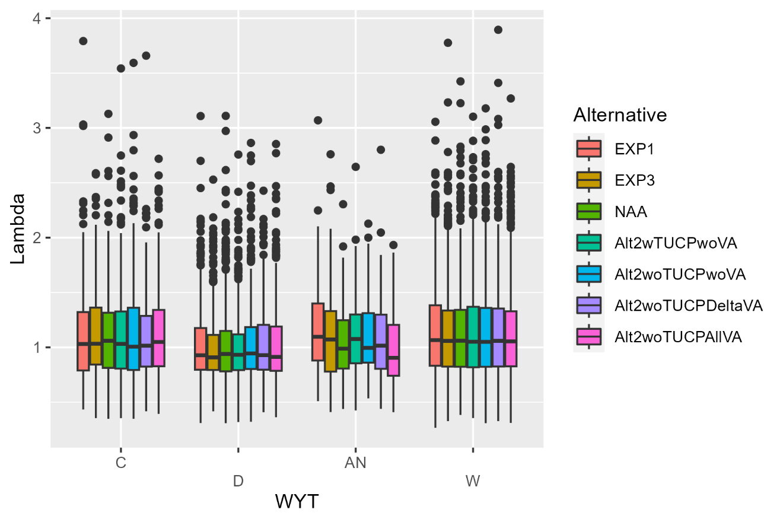

Figure 28. Predicted lambda values across water year types (Nt+1/Nt) for total spring-run spawner abundance in the Central Valley, including both natural- and hatchery-origin fish, across 100 stochastic model iterations.

#### Life stage-specific demographic parameters

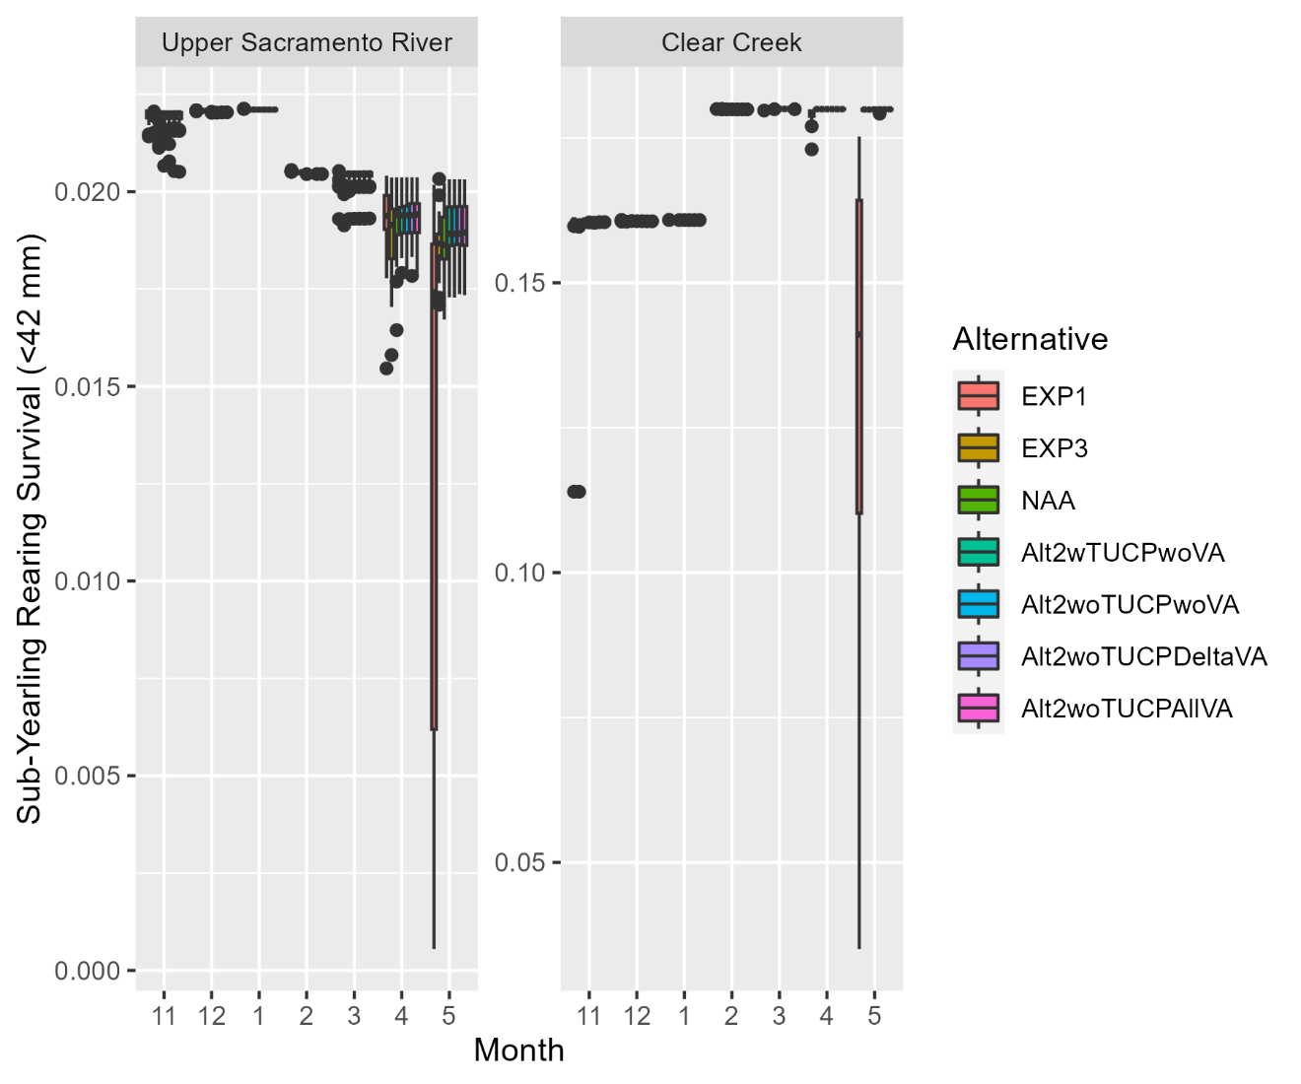

Figure 29. Predicted small, young-of-year, juvenile rearing survival for spring-run Chinook salmon in the Upper Sacramento River and Clear Creek from deterministic model runs.

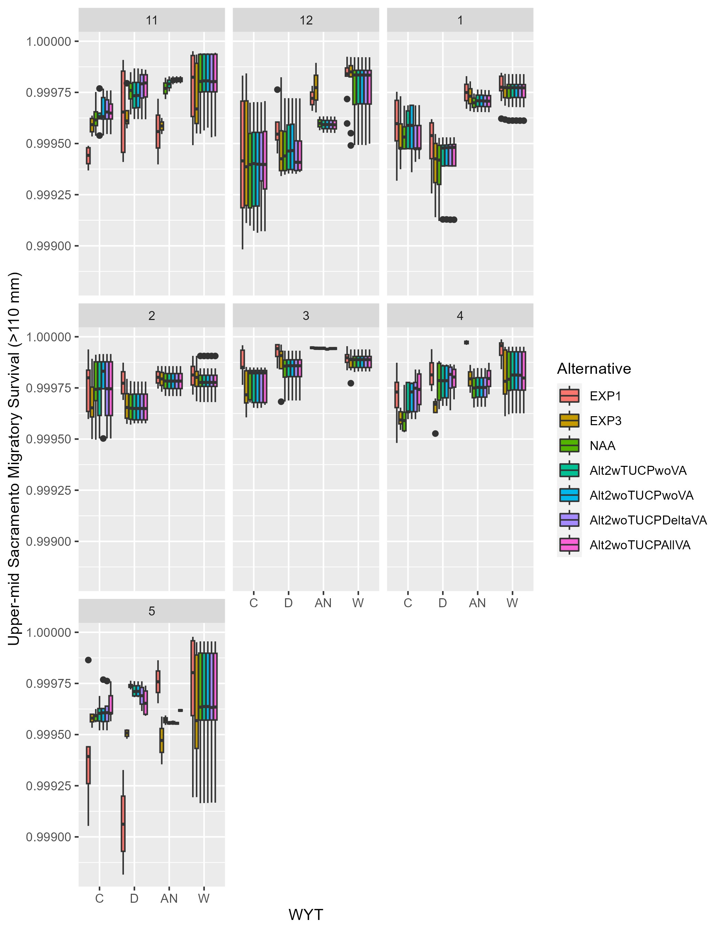

Figure 30. Predicted smolt migratory survival for spring-run Chinook salmon in the Upper-mid Sacramento River from deterministic model runs, faceted by month.

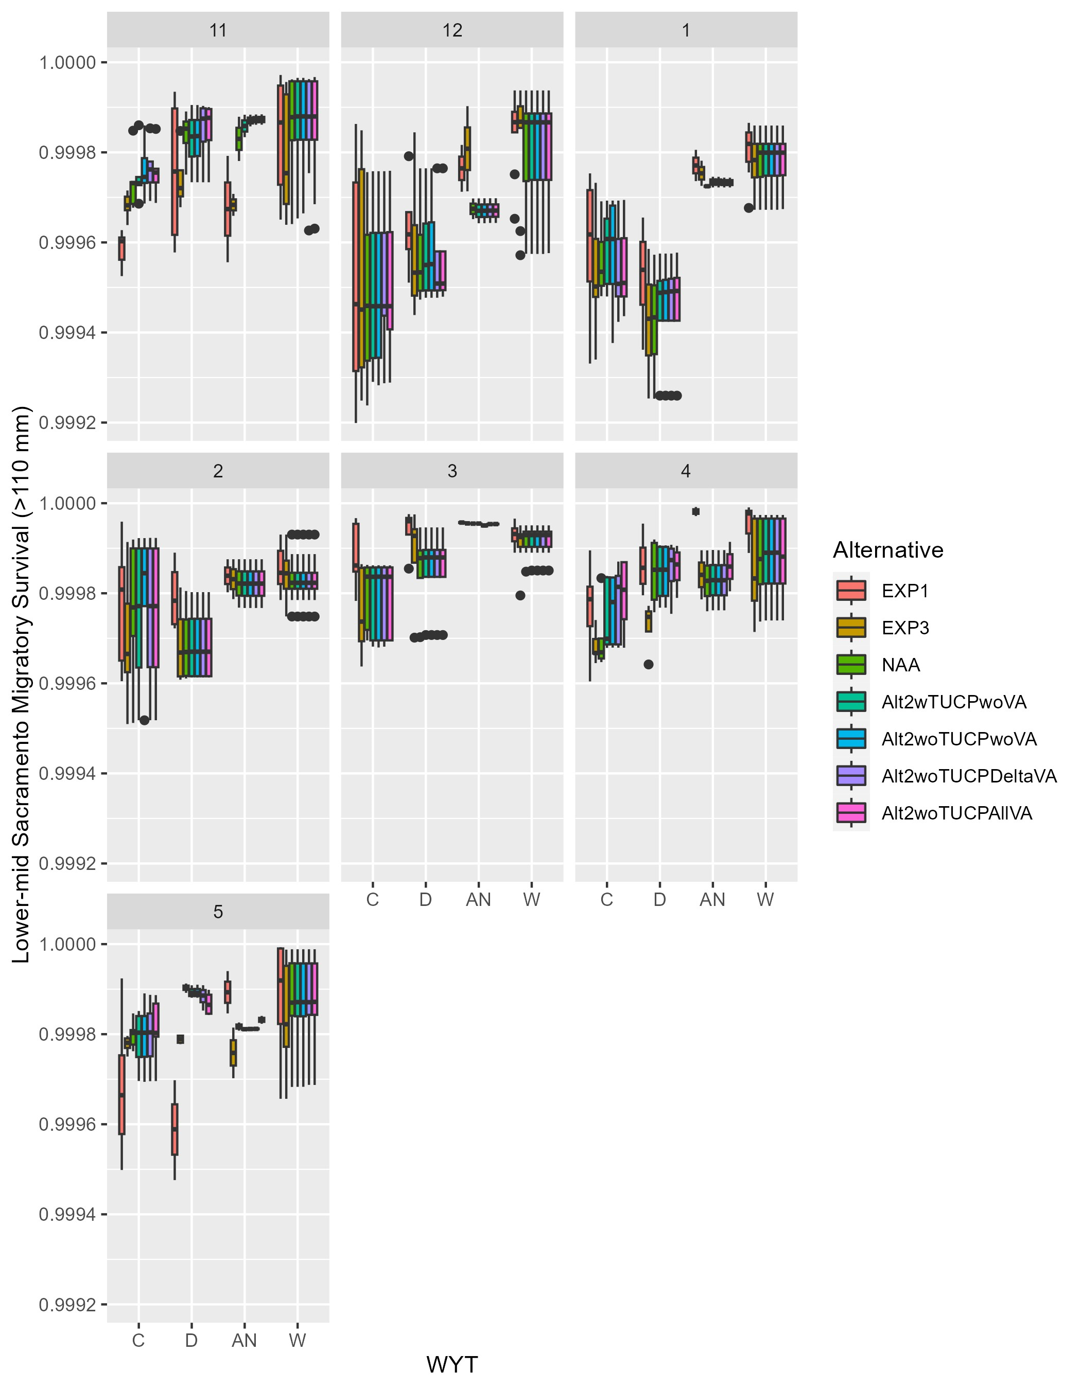

Figure 31. Predicted smolt migratory survival for spring-run Chinook salmon in the Lower-mid Sacramento River from deterministic model runs, faceted by month.

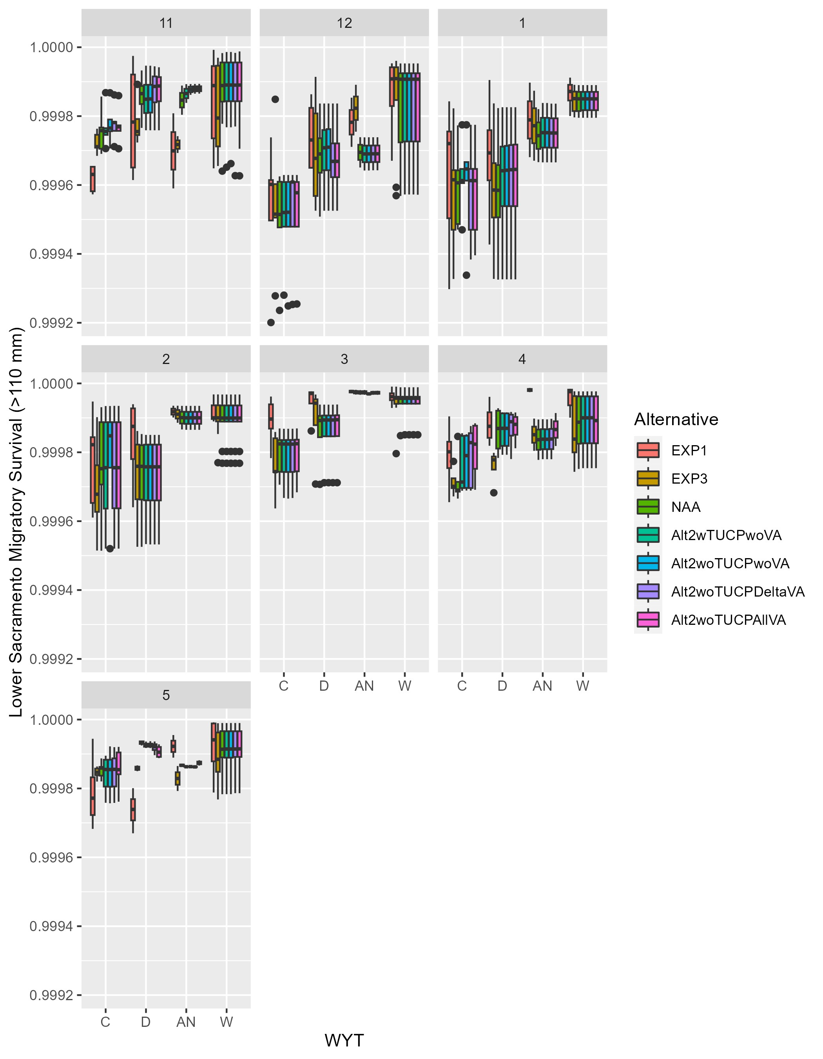

Figure 32. Predicted smolt migratory survival for spring-run Chinook salmon in the Lower Sacramento River from deterministic model runs, faceted by month.

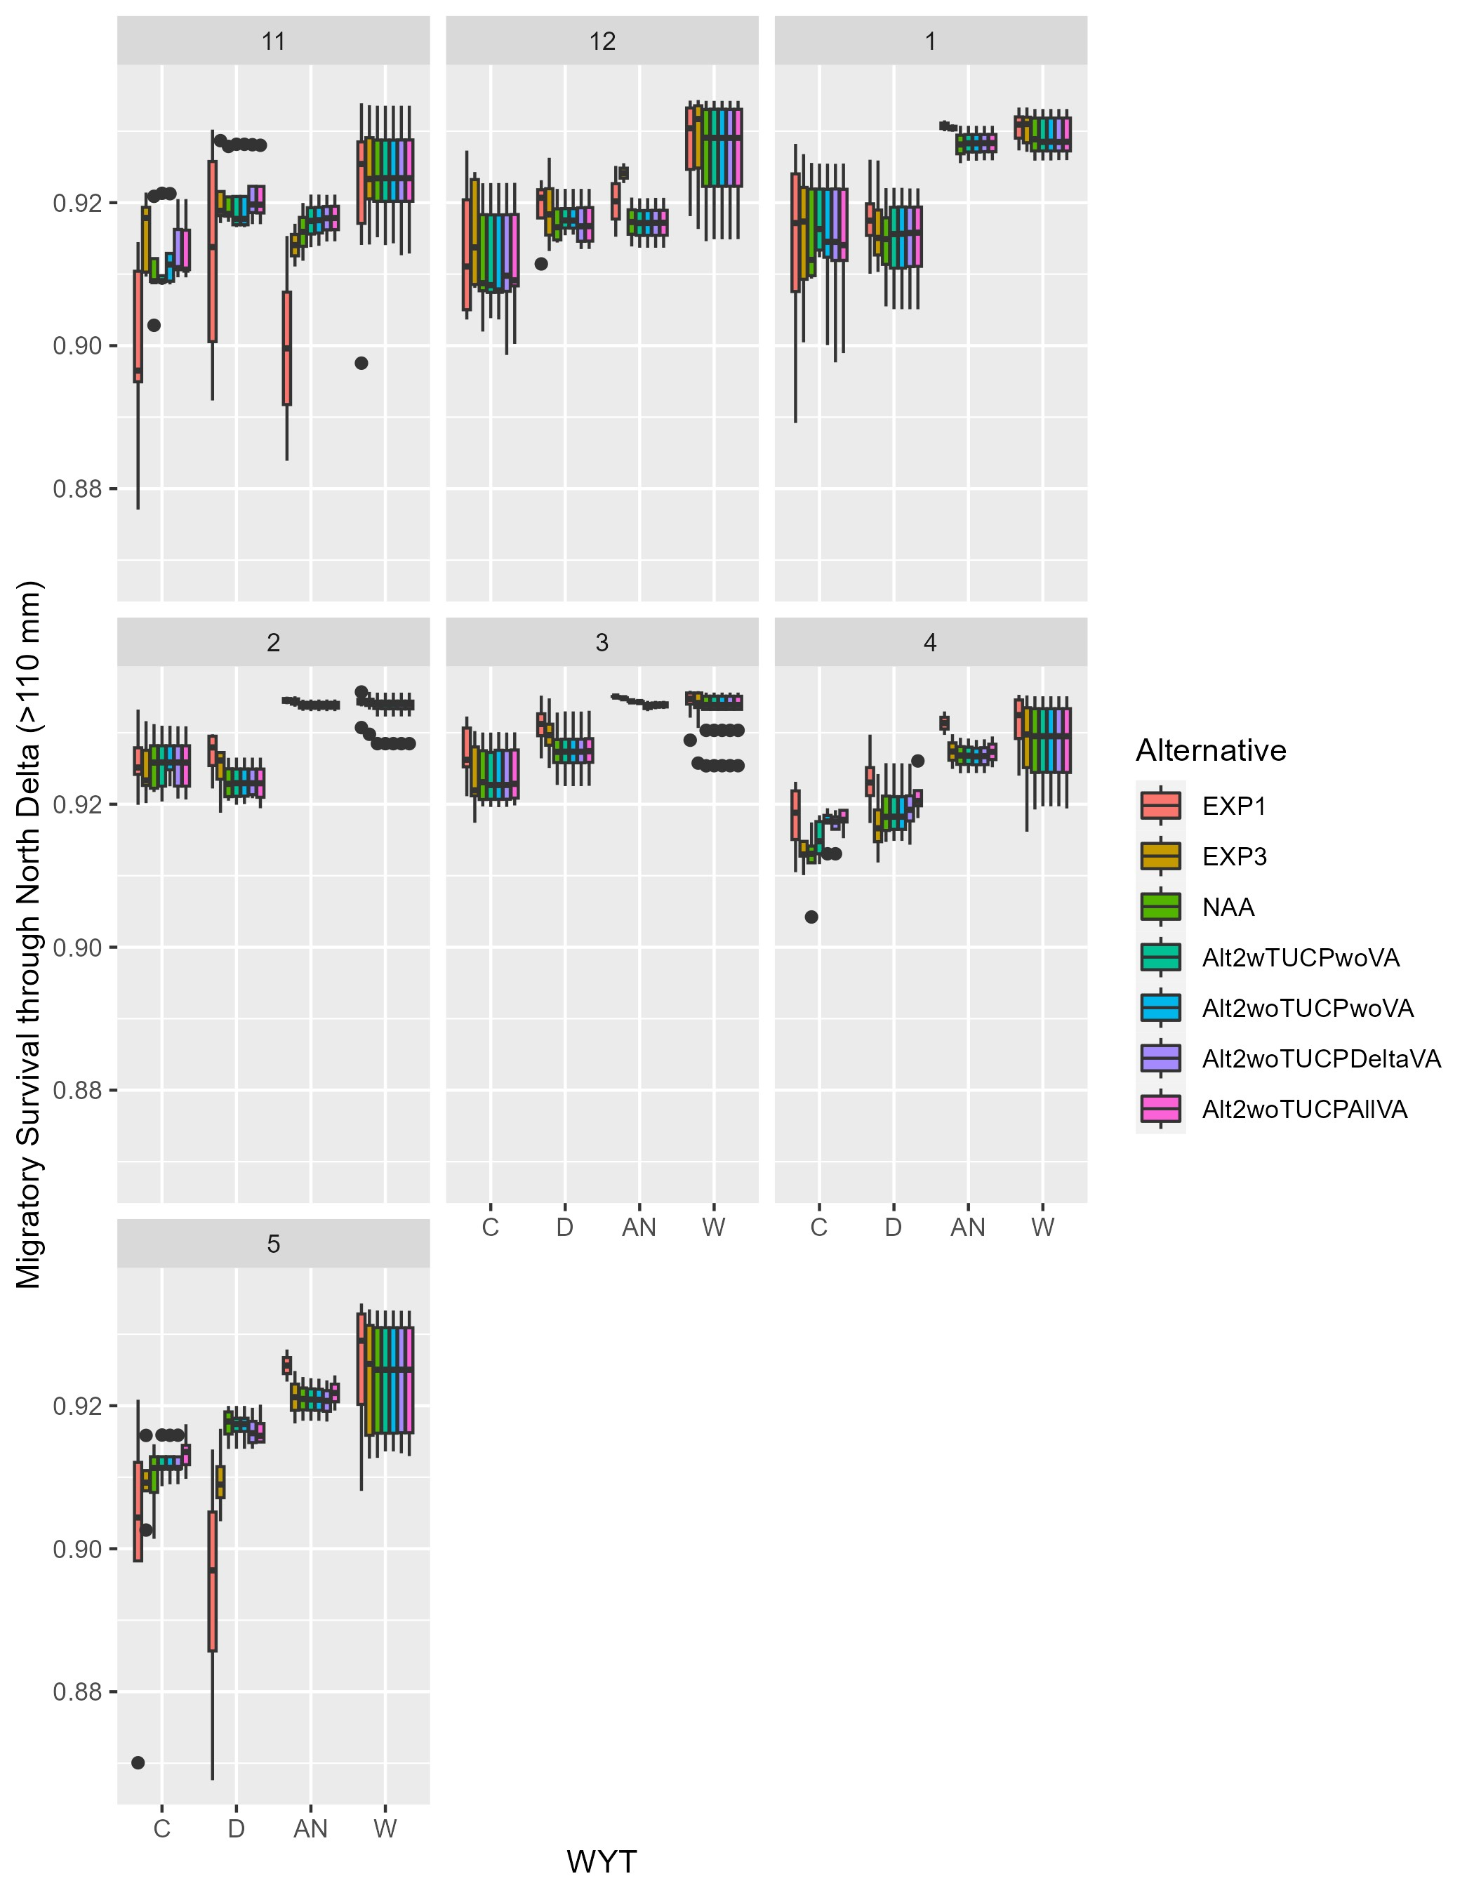

Figure 33. Predicted smolt migratory survival for spring-run Chinook salmon in the North Delta from deterministic model runs, faceted by month.

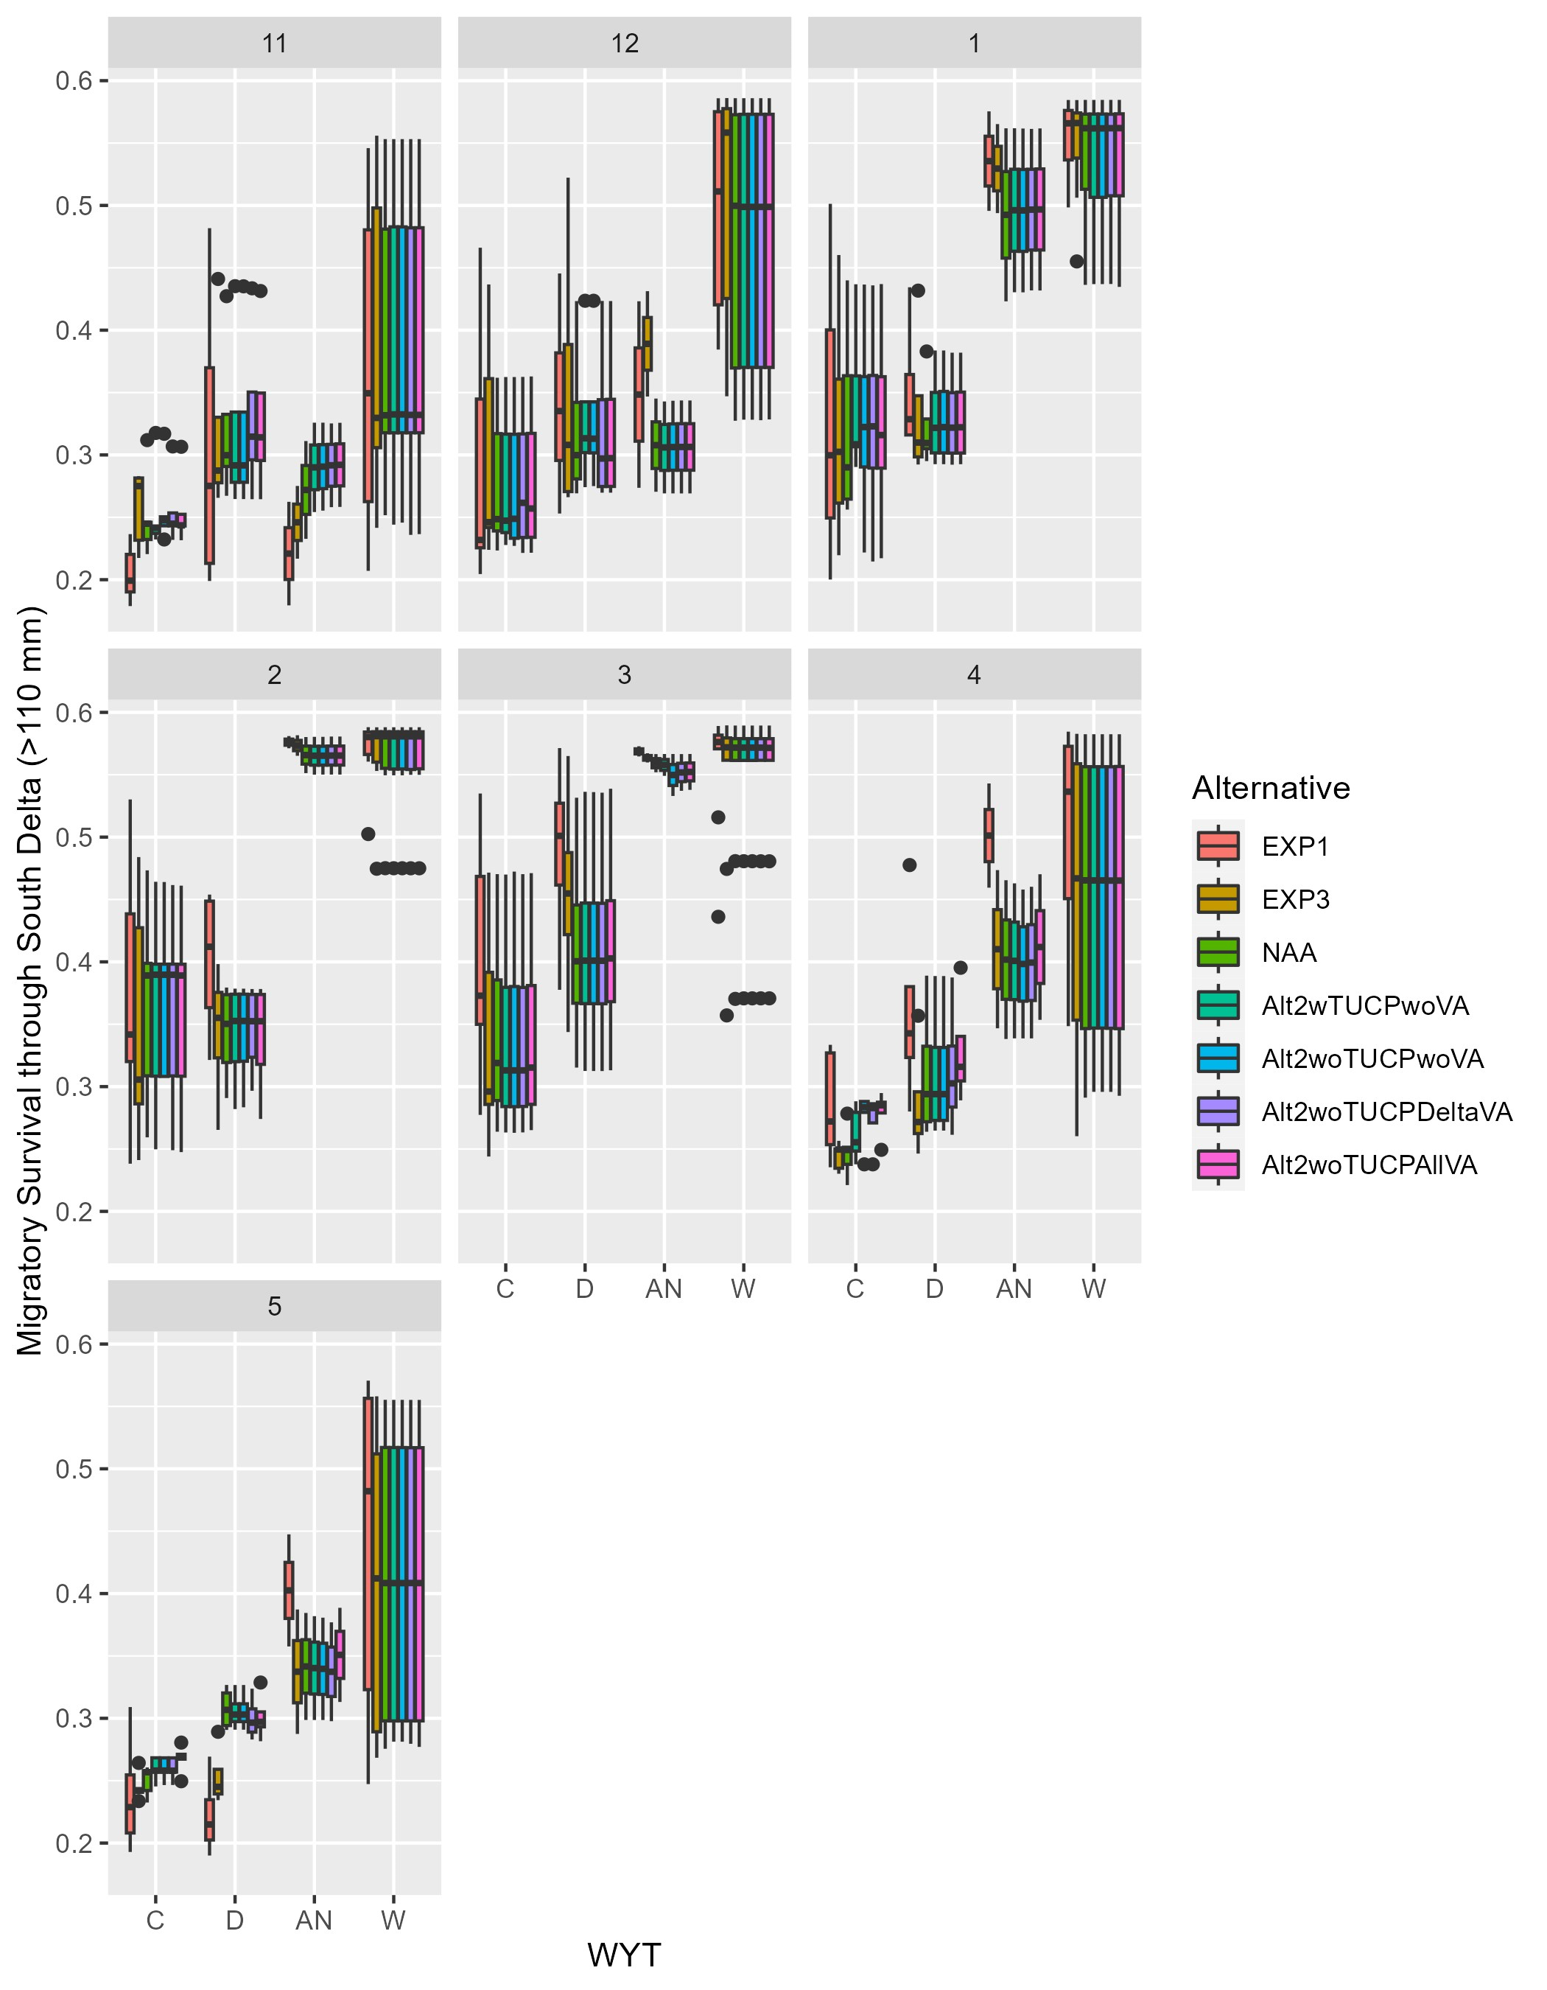

Figure 34. Predicted smolt migratory survival for spring-run Chinook salmon in the South Delta from deterministic model runs, faceted by month.

## References

Michel, C.J. 2019. Decoupling outmigration from marine survival indicates outsized influence of streamflow on cohort success for California’s Chinook salmon populations. Canadian Journal of Fisheries and Aquatic Sciences 76: 1398-1410.

National Marine Fisheries Service. 2019. Biological Opinion on Long-Term Operation of the Central Valley Project and the State Water Project. National Marine Fisheries Service, National Oceanic and Atmospheric Administration, U.S. Department of Commerce. WCRO-2016-00069

O’Farrell, M., Hendrix, N., and Mohr, M. 2016. An Evaluation of preseason abundance forecasts for Sacramento River winter Chinook salmon. Agenda Item D.2., Attachment 1.

Peterson, J.T., and Duarte, A. 2020. Decision analysis for greater insights into the development and evaluation of Chinook salmon restoration strategies in California’s Central Valley. Restoration Ecology 28(6): 1596-1609.